Name:

Compare and contrast these two images. What do you notice? What do you wonder?
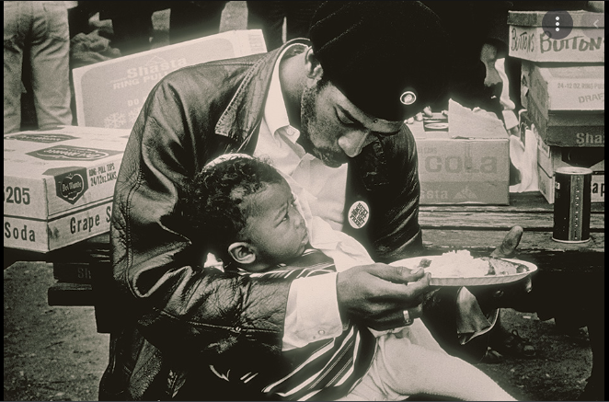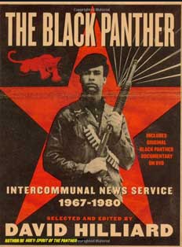

Image 1: Observations | Image 1: Inferences | Image 2: Observations | Image 2: Inferences
THE BLACK PANTHER PARTY
Ten Point Platform & Program, October 1966
WHAT WE WANT
WHAT WE BELIEVE*
1. WE WANT freedom. We want power to determine the destiny of our Black Community. WE BELIEVE that black people will not be free until we are able to determine our destiny.
2. WE WANT full employment for our people. WE BELIEVE that the federal government is responsible and obligated to give every man employment or a guaranteed income.
3. WE WANT an end to the robbery by the CAPITALIST of our Black Community. WE BELIEVE that this racist government has robbed us and now we are demanding the overdue debt of forty acres and two mules.
4. WE WANT decent housing, fit for the shelter of human beings. WE BELIEVE that if the white landlords will not give decent housing to our black community, then the housing and the land should be made into cooperatives so that our community, with government aid, can build and make decent housing for its people.
5. WE WANT education for our people that exposes the true nature of this decadent American society. We want an education that teaches us our true history and our role in the present-day society. WE BELIEVE in an educational system that will give to our people knowledge of self.
6. WE WANT all black men to be exempt from military service. WE BELIEVE that Black people should not be forced to fight in the military service to defend a racist government that does not protect us.
7. WE WANT an immediate end to POLICE BRUTALITY and MURDER of black people. WE BELIEVE we can end police brutality in our black community by organizing black self-defense groups that are dedicated to defending our black community from racist police oppression and brutality.
8. WE WANT freedom for all black men held in federal, state, county and city prisons and jails. WE BELIEVE that all black people should be released from the many jails and prisons because they have not received a fair and impartial trial.
9. WE WANT all black people when brought to trial to be tried in court by a jury of their peer group or people from their black communities, as defined by the Constitution of the United States. WE BELIEVE that the courts should follow the United States Constitution so that black people will receive fair trials.
10. WE WANT land, bread, housing, education, clothing, justice and peace.
source: http://www.itsabouttimebpp.com/home/bpp_program_platform.html *condensed from original

