Excerpts from “We’re going to defend ourselves” The Portland Chapter of the Black Panther Party and the Local Media Response – a study published by Boykoff and Gies for the Oregon Historical Society.

To analyze local coverage, we collected all the news output from the Oregonian and Oregon Journal between 1968 — the run-up to the formation of the Portland chapter — and 1973, when media coverage of the Portland Panthers ceased, a full seven years before the BPP free health clinic closed.

In 1971, the Oregonian had a daily circulation of nearly 247,000 and a Sunday circulation of slightly over 407,000. This was significant distribution in a city with a population of 382,619 people. The afternoon paper, the Oregon Journal,...in 1971,[the] daily circulation was 138,000, with Sunday circulation at 129,000.

[T]he Black Panther Party only appeared in ninety-three articles: sixty-one in the Oregonian and thirty-two in the Oregon Journal.

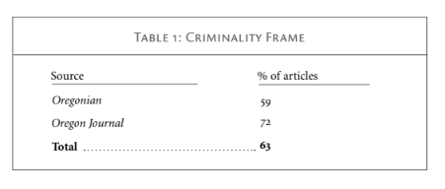
Four contentious episodes involving the Black Panther Party generated a majority of the articles in the dataset: Kent Ford’s arrest and beating at the hands of Portland police in 1969; the police shooting of Albert Williams at Panther headquarters in February 1970; Black Panther Party picketing of McDonald’s in summer 1970; and the imbroglio over whether to issue the Fred Hampton People’s Health Clinic a fund solicitation permit in the winter of 1970–1971.

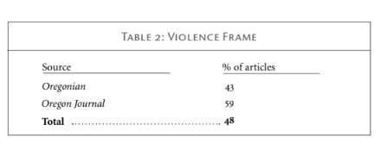
The Black Panther Party was frequently depicted as engaging in violence or threatening to undertake violent acts — such as arson, shootings, or beatings — and instigating violent clashes with the police. Nearly half of all articles (48 percent) employed the Violence Frame.

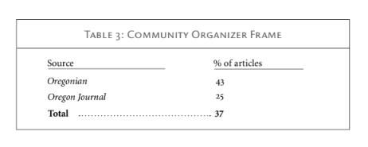

[R]oughly a third of Oregon newspaper articles made note of the Panthers’ community outreach programs. Nevertheless, most of these articles — generally brief, neutral, and carrying no byline — appear to have been taken directly from press releases generated by the Party.

Source: Boykoff, J., & Gies, M. (2010). “We’re going to defend ourselves”: The Portland Chapter of the Black Panther Party and the Local Media Response. Oregon Historical Quarterly, 111(3), 278–311.

