QUEEN NZINGA (1583-1663)
JUNE 16, 2009 / CONTRIBUTED BY: JESSICA SNETHEN
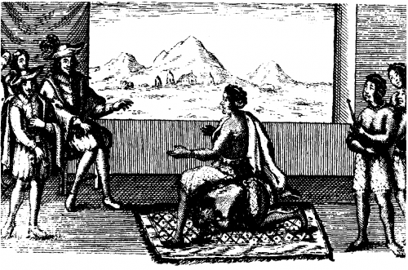
Queen Njinga meeting with Portuguese Governor Joao Corria de Sousa, 1622
Public domain image
Queen Nzinga (Nzinga Mbande), the monarch of the Mbundu people, was a resilient leader who fought against the Portuguese and their expanding slave trade in Central Africa.
During the late 16th Century, the French and the English threatened the Portuguese near monopoly on the sources of slaves along the West African coast, forcing it to seek new areas for exploitation. By 1580 they had already established a trading relationship with Afonso I in the nearby Kongo Kingdom. They then turned to Angola, south of the Kongo.
The Portuguese established a fort and settlement at Luanda in 1617, encroaching on Mbundu land. In 1622 they invited Ngola (King) Mbande to attend a peace conference there to end the hostilities with the Mbundu. Mbande sent his sister Nzinga to represent him in a meeting with Portuguese Governor Joao Corria de Sousa. Nzinga was aware of her diplomatically awkward position. She knew of events in the Kongo which had led to Portuguese domination of the nominally independent nation. She also recognized, however, that to refuse to trade with the Portuguese would remove a potential ally and the major source of guns for her own state.
In the first of a series of meetings Nzinga sought to establish her equality with the representative of the Portugal crown. Noting that the only chair in the room belonged to Governor Corria, she immediately motioned to one of her assistants who fell on her hands and knees and served as a chair for Nzinga for the rest of the meeting.
Despite that display, Nzinga made accommodations with the Portuguese. She converted to Christianity and adopted the name Dona Anna de Souza. She was baptized in honor of the governor’s wife who also became her godmother. Shortly afterwards Nzinga urged a reluctant Ngola Mbande to order the conversion of his people to Christianity.
In 1626 Nzinga became Queen of the Mbundu when her brother committed suicide in the face of rising Portuguese demands for slave trade concessions. Nzinga, however, refused to allow them to control her nation. In 1627, after forming alliances with former rival states, she led her army against the Portuguese, initiating a thirty-year war against them. She exploited European rivalry by forging an alliance with the Dutch who had conquered Luanda in 1641. With their help, Nzinga defeated a Portuguese army in 1647. When the Dutch were in turn defeated by the Portuguese the following year and withdrew from Central Africa, Nzinga continued her struggle against the Portuguese. Now in her 60s she still personally led troops in battle. She also orchestrated guerilla attacks on the Portuguese which would continue long after her death and inspire the ultimately successful 20th Century armed resistance against the Portuguese that resulted in independent Angola in 1975.
Despite repeated attempts by the Portuguese and their allies to capture or kill Queen Nzinga, she died peacefully in her eighties on December 17, 1663.

Subjects:
Global African History, People

Terms:
Africa-Democratic Republic of the Congo (Zaire), Europe - Great Britain - England, Gender - Women, Europe - France, Europe - Netherlands (Holland), Europe - Portugal, Africa - Angola, 17th Century (1600-1699), Government - Country Ruler/Leader, Political Leader-Queen

Source

