1.1: Wilhelm Conrad Rontgen

Wilhelm Conrad Roentgen:
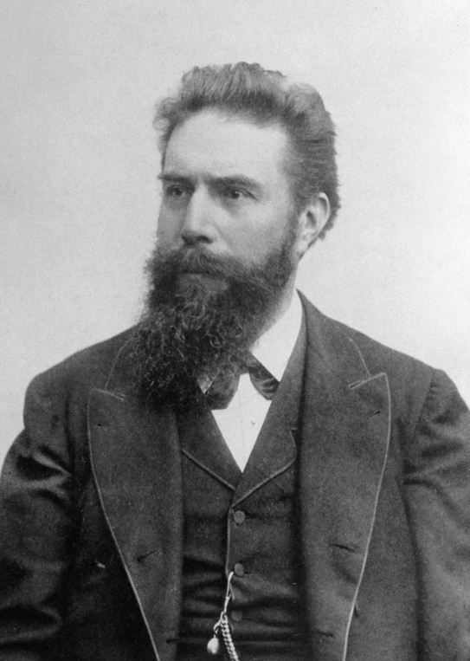
"¬ Wilhelm Conrad Roentgen Photo" from Life Photo Archive is public domain

Wilhelm Conrad Roentgen was the German engineer and physicist credited with the discovery of X-ray in 1895. Rontgen’s discovery is one of the greatest scientific discoveries leading to diagnostic advances in the medical industry and later in the field of non-destructive testing. Rontgen generated the first medical X-ray image of his wife’s hand pictured below:
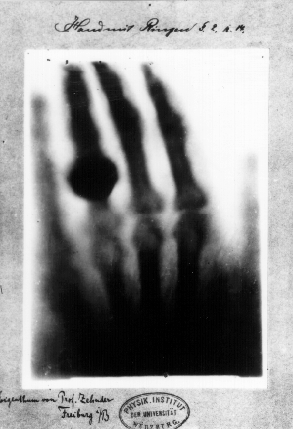
"First medical X-ray by Wilhelm Röntgen of his wife Anna Bertha Ludwig's hand" by Wilhelm Röntgen is in the Public Domain
The following are links to articles and videos providing detailed information about Roentgen – the German engineer & Physicist credited with the discovery of X-ray in 1895.

  - American Journal of Roentgenology Article: https://www.ajronline.org/doi/pdf/10.2214/ajr.165.6.7484601
  - Wired Magazine Article: https://www.wired.com/2010/11/1108roentgen-stumbles-x-ray/
  - Biographical Youtube Video: https://www.youtube.com/watch?v=XcjVRgthqvo
  - Biographical Youtube Video: https://youtu.be/_PXpy6clWxI

