1.2: Marie & Pierre Curie

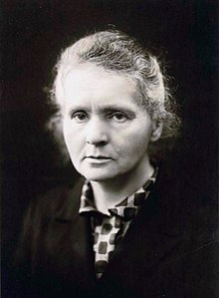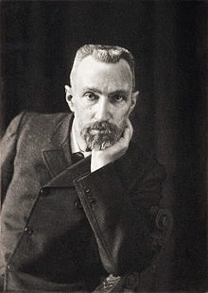
"Marie Curie" by Unknown is in the Public Domain "Pierre Curie" by Unknown is in the Public Domain
Marie Curie, one of the most honored scientists of all time, is credited for the discovery of radium and received the 1903 Nobel Prize in physics along with her husband Pierre and fellow physicist Henri Becquerel. In 1911 Curie received the Nobel Prize in chemistry for her scientific research and breakthroughs with radium, and polonium making her not only the first woman in history to receive the Nobel Prize, but also the only person – man or woman – to ever receive Nobel Prizes in two separate disciplines. Her name lives on with “Curie”, (Ci) used as a unit of radioactivity.
The following are links to a video and articles providing detailed information about Marie Curie and her tremendous contribution to science.
- Wikipedia article on Marie Curie: https://en.wikipedia.org/wiki/Marie_Curie
- Marie Curie Documentary, YouTube video https://www.youtube.com/watch?v=0vTRrZU-LKQ&t=15s

