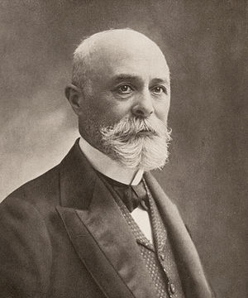
"Henri Becquerel" by Paul Nadar is in the Public Domain

Henri Becquerel was a French physicist performing ground-breaking research at the same time as Wilhelm Rontgen and the Curies. His work in the discovery of “spontaneous radioactivity” earned him a share of the 1903 Physics Nobel Prize along with Marie and Pierre Curie. Similar to Curie, Becquerel has a unit named after him for radioactivity – the SI unit “Becquerel” (Bq)

The following are links to documents and videos on the life and scientific contributions made by Henri Becquerel.
- The Nobel Prize Organization magazine Article: https://www.nobelprize.org/prizes/physics/1903/becquerel/biographical/

- Wikipedia Biography of Henri Becquerel: https://en.wikipedia.org/wiki/Henri_Becquerel

- YouTube Video biography of Henri Becquerel: https://www.youtube.com/watch?v=GJz278yaKvw

