1.4: Radiation History in the U.S.

Edison & Dally
In the late 1890’s Thomas Edison learned of the recently discovered “X-rays” and began to research and experiment along with his research assistant Clarence Dally. Their lack of understanding of the hazards involved with X-radiation led to the painful, early death of Dally. Read more in Smithsonian.com:
https://www.smithsonianmag.com/history/clarence-dally-the-man-who-gave-thomas-edison-x-ray-vision-123713565/

Shoe - Fitting Fluoroscopes:

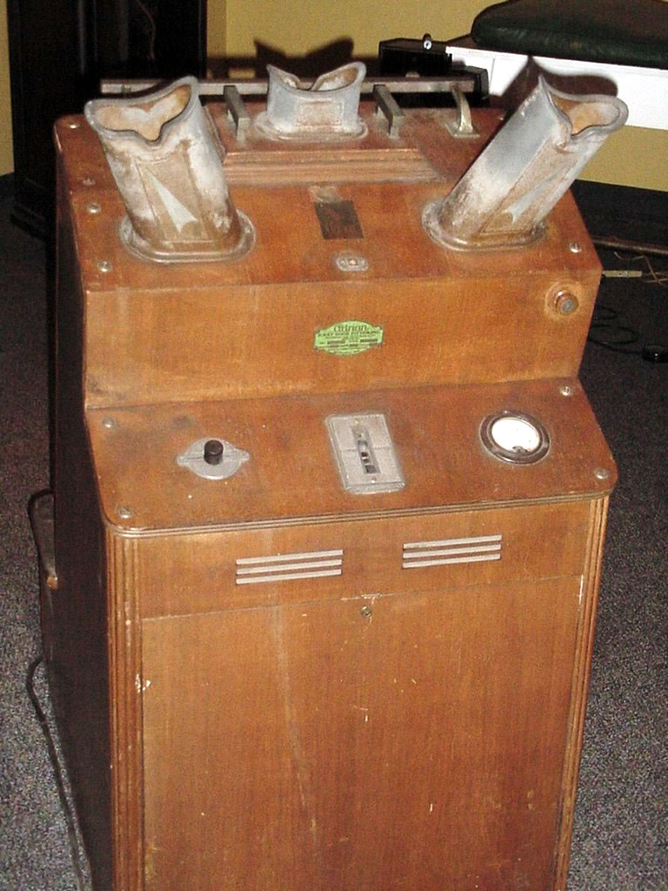
"Shoe Fitting Fluoroscope" by wikipedia is in the Public Domain

From the 1920’s well into the 1950’s shoe companies used fluoroscopes like the one pictured above to “look” into the feet of potential customers in an effort to ensure a better shoe fit for the customer. While mostly a gimmick to generate sales, the fluoroscopes also generated dangerous levels of radiation and exposed thousands of people unnecessarily – all in the name of marketing and sales.

By the late 1940’s, Scientists and health regulatory agencies around the world began to research and question the safety of these shoe fitting fluoroscopes. By 1953 the US FDA recommended not using the machines on children and in 1957 Pennsylvania was the first state to ban the use of the machines altogether. The last recorded Shoe fitting X-ray machine still in use was in Boston in the early 1970’s. For more information, see the following videos:

- Shoe store fluoroscopes video:
  - https://www.youtube.com/watch?v=QVlEXd9w7vk
- X-ray Shoe Fit Check 1920’s:
  - https://www.youtube.com/watch?v=wbMN6jueU1A

