Learning Objective:
- A quick snapshot at the basic radiological safety concepts that will be at the center of the entire Radiation Safety Course
- Understand and apply the Inverse Square Law as it pertains to Radiation Safety
- Learn how we protect ourselves: Time, Distance & Shielding
Resources:
- NRC: https://www.nrc.gov/
Learning Activities:
- https://www.nrc.gov/reading-rm/basic-ref/glossary/alara.html
  - ALARA: As defined in Title 10, Section 20.1003, of the Code of Federal Regulations (10 CFR 20.1003), ALARA is an acronym for "as low as (is) reasonably achievable," which means making every reasonable effort to maintain exposures to ionizing radiation as far below the dose limits as practical, consistent with the purpose for which the licensed activity is undertaken, taking into account the state of technology, the economics of improvements in relation to state of technology, the economics of improvements in relation to benefits to the public health and safety, and other societal and socioeconomic considerations, and in relation to utilization of nuclear energy and licensed materials in the public interest.

- 1977 - ALARA became the law!
- Complete ALARA article reviews (see worksheet)
- With ALARA in mind, let’s take a look at Time, Distance & Shielding
  - The concept and practical applications of Time, distance & Shielding are not overly complicated and make sense when keeping the public safe and ourselves from radiation over-exposure. Take a few minutes to read the following explanation on the NRC website and then write a brief summary of what think are the main points the NRC wants you as a radiographer to “take-away” from their information.
    - https://www.nrc.gov/about-nrc/radiation/protects-you/protection-principles.html#tds
  - Summary:
- Math: …and the math helps us to determine when we’ve met ALARA. Radiographers use laws of physical science coupled with mathematics to keep their radiation exposure “As Low As is Reasonable Achievable.”

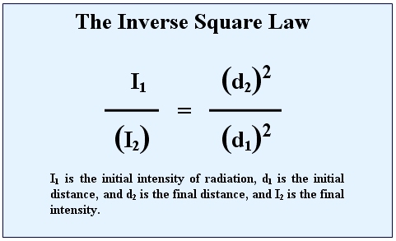
  - Radiographers use the Inverse Square law to solve for safe DISTANCES (d) and to solve for the INTENSITY (I) of radiation. Think Safety. Think: Time, Distance, Shielding

  - Let’s take a look at the NRC’s examples of how Radiographers apply the Inverse Square Law to calculate radiation Dosage.
    - https://www.nrc.gov/docs/ML1121/ML11210B521.pdf
  - To further break down this formula for determining safe distance and safe intensities, we will spend more time later practicing the math.
  - One more mathematical tool radiographers use in their time, distance, SHIELDING tool box is a shielding formula known as the Half Value Layer formula which calculates the thickness, and number of layers of a shielding material required to reduce the radiation intensity to a safe dose rate (2 mR/hr) the formula is as follows:
  - Half Value Layer (HVL):
$HVL=\frac{LOG [\frac{I_{o}}{I_{d}}]}{LOG2}$ I_{o} = Original Intensity
I_{d} = Desired Intensity

In your own words, explain why radiation intensity decreases over distance.

