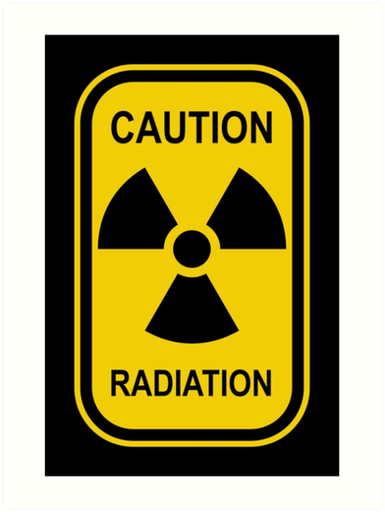
Activity: Named after Nobel Prize recipient Marie Curie, the curie (ci) is the unit used to describe the rate of decay or activity, of a radioactive material in disintegrations per second. One curie equals 37,000,000,000 (37 billion) disintegrations per second. In the SI system, the Becquerel (Bq) is the unit of activity, which is equal to one disintegration per second.

Specific Activity: The specific activity of an isotope is used to describe the activity per unit of mass or weight (i.e. Curies per gram or Becquerel’s per gram)
A high specific activity indicates that a source of a given activity will have a smaller physical size (smaller focal spot) which will yield better definition with radiographs.
In addition, there is less self absorption in high specific activity sources because there is less matter to attenuate or absorb the radiation.

One of the phenomena radiographers deal with is how rapidly the rate of decay affects the usefulness and associated hazards of a radioactive isotope. To help define and quantify this dilemma, the radioactive Half-Life is as follows:

Half-life (symbol t1⁄2) is the time required for a quantity of an isotope to reduce to half its initial value. The term is commonly used in nuclear physics to describe how quickly unstable atoms undergo, or how long stable atoms survive, radioactive decay. The term is also used more generally to characterize any type of exponential or non-exponential decay. For example, the medical sciences refer to the biological half-life of drugs and other chemicals in the human body. The converse of half-life is doubling time.
The original term, half-life period, dating to Ernest Rutherford's discovery of the principle in 1907, was shortened to half-life in the early 1950s.[1] Rutherford applied the principle of a radioactive element's half-life to studies of age determination of rocks by measuring the decay period of radium to lead-206.
So why does the radiographer care about half-life? There are two reasons:
- The radiographer’s safety protocols are dependent on calculating safe distances (Inverse Square Law Formula) and known radiation emissivity at any given distance from the gamma source. This can only be accomplished if the number of curies of the source is known. For example, if a radiographer is using a 100-curie (ci) source of Iridium – 192 to take radiographs, the technician will know 5.2 R/h are emitted for each ci at 1 foot; therefore, a little math tells us that 100ci source multiplied by 5.2 R/h/ci has a total of 520 R/h. Appropriate shielding and safe distances (ALARA) will be calculated based on these calculated numbers.
- Radiographers have the task of taking pictures – radiographs – of whatever job they are working (Aerospace parts, oil line pipe welds, bridge structures, nuclear cooling tubes, etc..) As in the safety protocols in item #1 above, radiographers must calculate exposure times (how long to expose film and DDA’s to the gamma radiation)
Now, let’s just fast forward the scenarios above 74.3 days (the half-life of Ir-192) and now our 100 ci source has disintegrated into 50 ci from the original 100 ci source, all of the safety protocols and exposure times have changed. Less shielding and distance are needed but more exposure time is needed to take the same radiographs.

ALARA: maintaining our individual radiation exposure to “As Low As is Reasonably Achievable” involves the principal of Time, Distance and Shielding. As has been demonstrated throughout this radiation safety course, scientific and mathematical principals are the tools we use to determine what exactly is a safe Time or Distance as it relates to radiation exposure. Likewise, we use mathematical tools to determine the value of our radiation Shielding to determine the Half-Value Layers (HVL).
HVL (Half Value Layer): The amount (thickness) of a given shielding material needed to reduce the radiation emissivity by one-half its value. We use the following math formula to determine the how thick of material it will take to reduce the radiation to a safe rate of emissivity.

HVL Formula: I_{o} = Original Intensity I_{d} = Desired intensity
$$Log[\frac{Io}{Id}]/Log2$$
What the HVL formula above accomplishes for the radiographer is how many HVL’s are needed to reduce an original intensity to a desired intensity. For instance, in our Radiography lab the lead lining in our 300 KV X-ray cabinets was calculated to a thick ness that would provide an emissivity of 2mR/hr or less at one inch from any exterior point on the cabinet. However, how do we know how much lead, steel or concrete to use?

The chart below shows approximately how thick the shielding material needs to be in order to reduce the radiation emissivity by one-half. It is important to note that different gamma sources require differing thicknesses of shielding to achieve the HVL. Also, note the most common shielding used is lead, iron, and concrete, but a few others are included as they are the preferred shielding in some applications. Tungsten and depleted uranium shield the isotopes used in portable gamma radiograph “cameras” and water is a shielding material of choice in nuclear reactors.

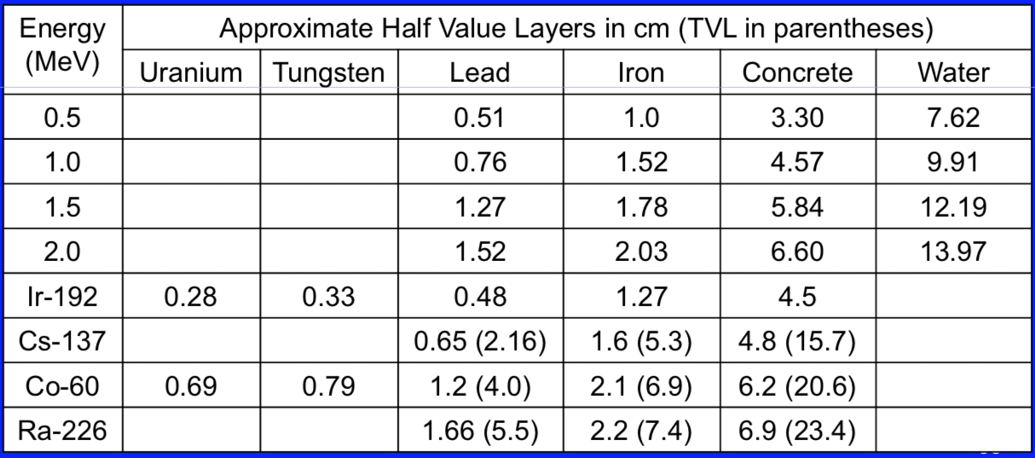

Wikipedia image
https://www.google.com/search?q=half+thickness+of+lead+for+gamma+rays&rlz=1C1CHBF_enUS706US706&source=lnms&tbm=isch&sa=X&ved=0ahUKEwji2O6AtcThAhUT2VQKHdX0Db0Q_AUIDigB&biw=1254&bih=882#imgrc=deXOg8my19OkBM:

