The NRC provides detailed information on the signage to be used for every level and type of Radiation safety situation. It is the radiographer’s responsibility to recognize and understand the significance of the variety of signs. The NRC dictates the color, wording, size, and geometric shape of Radiation caution signs in NRC Part 20.1901 as follows: https://www.nrc.gov/reading-rm/doc-collections/cfr/part020/part020-1901.html

(a) Standard radiation symbol. Unless otherwise authorized by the Commission, the symbol prescribed by this part shall use the colors magenta, purple, or black on yellow background. The symbol prescribed by this part is the three-bladed design:
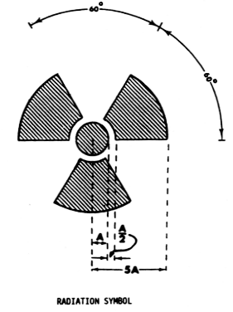
(1) Cross-hatched area is to be magenta, or purple, or black, and
(2) The background is to be yellow.
(b) Exception to color requirements for standard radiation symbol. Notwithstanding the requirements of paragraph (a) of this section, licensees are authorized to label sources, source holders, or device components containing sources of licensed materials that are subjected to high temperatures, with conspicuously etched or stamped radiation caution symbols and without a color requirement.
(c) Additional information on signs and labels. In addition to the contents of signs and labels prescribed in this part, the licensee may provide, on or near the required signs and labels, additional information, as appropriate, to make individuals aware of potential radiation exposures and to minimize the exposures.
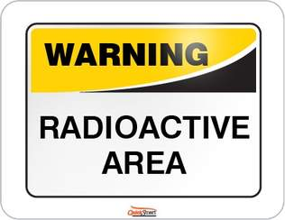
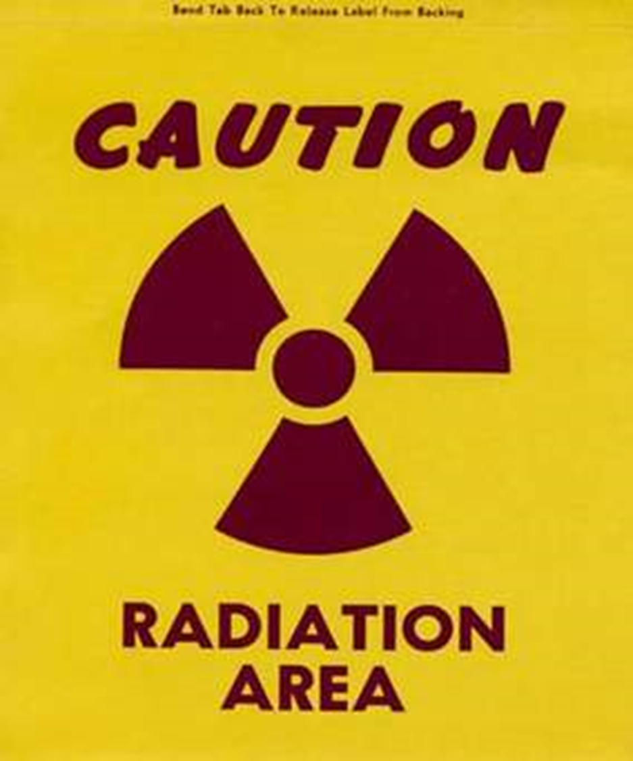
Radiation Caution Signs are divided into the categories of Radiation Area and Radioactive Material
Radioactive Material container signage and labeling is specified in NRC Part 20.1904 and can be found at the following url: https://www.nrc.gov/reading-rm/doc-collections/cfr/part020/part020-1904.html
(a) The licensee shall ensure that each container of licensed material bears a durable, clearly visible label bearing the radiation symbol and the words "CAUTION, RADIOACTIVE MATERIAL" or "DANGER, RADIOACTIVE MATERIAL." The label must also provide sufficient information (such as the radionuclide(s) present, an estimate of the quantity of radioactivity, the date for which the activity is estimated, radiation levels, kinds of materials, and mass enrichment) to permit individuals handling or using the containers, or working in the vicinity of the containers, to take precautions to avoid or minimize exposures.
(b) Each licensee shall, prior to removal or disposal of empty uncontaminated containers to unrestricted areas, remove or deface the radioactive material label or otherwise clearly indicate that the container no longer contains radioactive materials.
The NRC divides Radioactive Signage (including shipping labels) into the following categories:
- Radioactive White - I Label – radiation level at package surface is less than or equal to 0.5 mr/hr.
  - 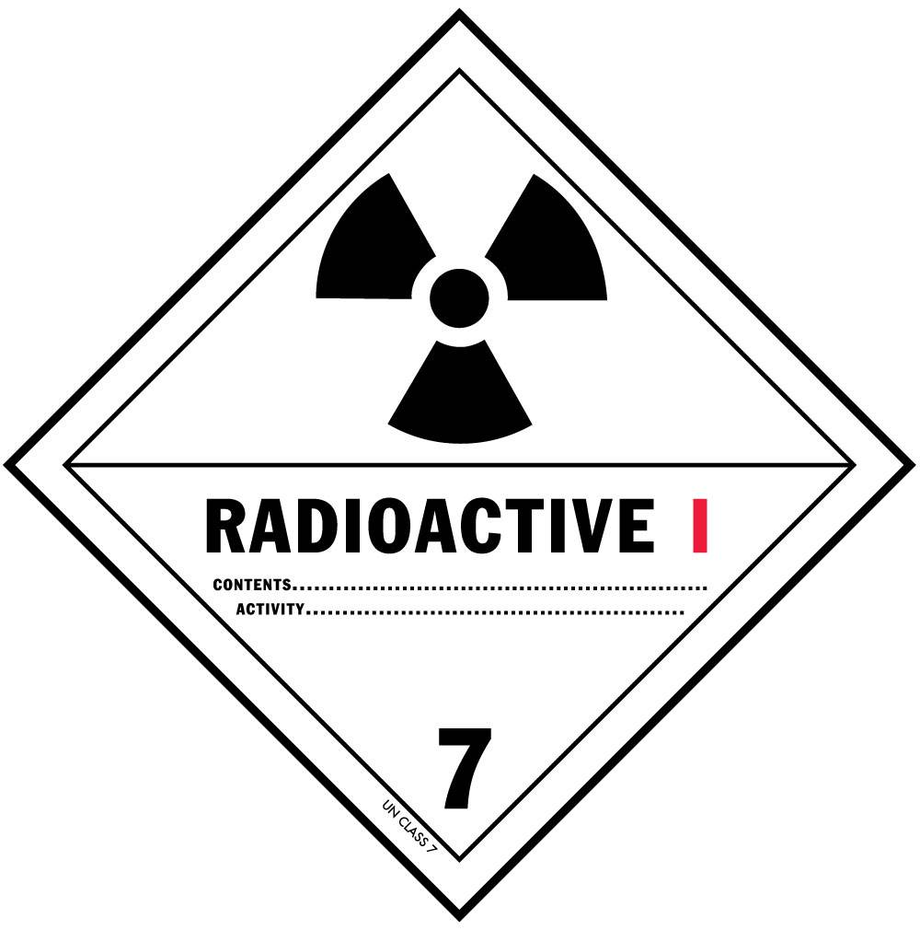
- Radioactive Yellow – II Label - radiation level at package surface is greater than 0.5 mr/hr but is less than or equal to 50.0 mr/hr
  - 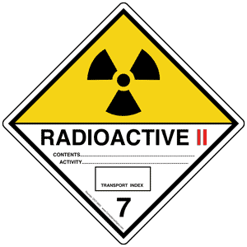
- Radioactive Yellow – II Label - radiation level at package surface is greater than 0.5 mr/hr but is less than or equal to 50.0 mr/hr
  - 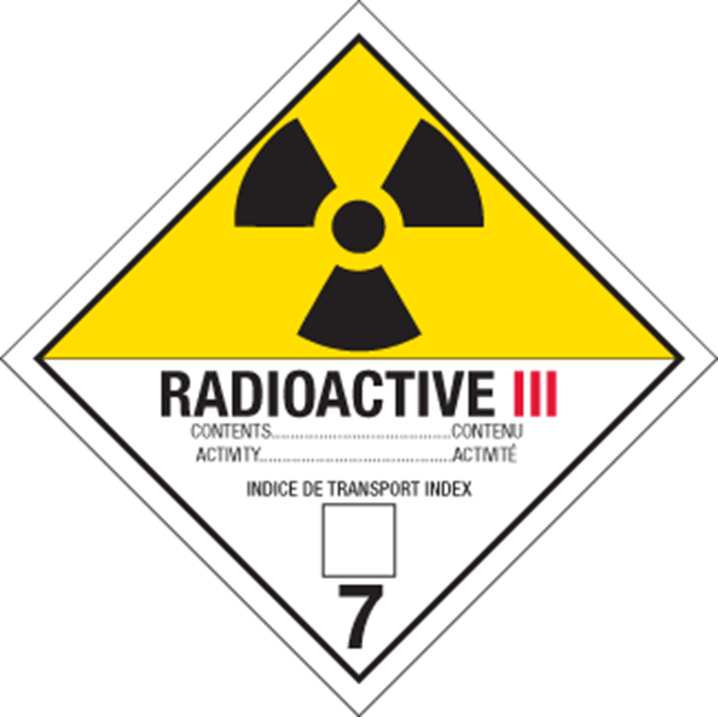

Placards must be displayed on both sides and both ends of motor vehicle, freight containers, and rail cars when used for transporting radioactive materials bearing a “RADIOACTIVE YELLOW III” label as shown below: https://www.nrc.gov/docs/ML1124/ML11245A185.pdf
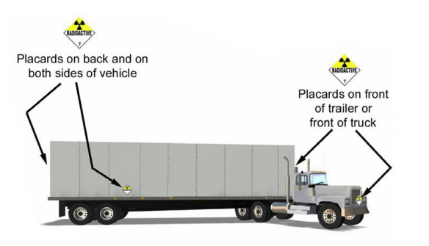

Radiation Areas are covered in NRC Part 20.1003 and defined as follows: https://www.nrc.gov/reading-rm/doc-collections/cfr/part020/part020-1003.html
Radiation area means an area, accessible to individuals, in which radiation levels could result in an individual receiving a dose equivalent in excess of 0.005 rem (0.05 mSv) in 1 hour at 30 centimeters from the radiation source or from any surface that the radiation penetrates.
Furthermore, a designation of “High Radiation Area” is spelled out in NRC Part 20.1003 as follows:
High radiation area means an area, accessible to individuals, in which radiation levels from radiation sources external to the body could result in an individual receiving a dose equivalent in excess of 0.1 rem (1 mSv) in 1 hour at 30 centimeters from the radiation source or 30 centimeters from any surface that the radiation penetrates.
