Acute radiation exposure is when an individual receives a high radiation dose over a relatively short period of time. Acute radiation exposure also called Acute Radiation Syndrome (ARS). ARS results when an individual receives a whole body exposure of 100 to 200 Rems or more (Roentgen Equivalent Man) over a 24-hour period of time. The table below shows the likely symptoms associated with differing levels of exposure.
Biological Effects:
- Somatic Effects: a person receiving somatic effects might exhibit prompt symptoms such as minor to severe skin burns, cataracts on the eyes, and even severe internal organ and blood damage. A person might also experience delayed somatic effects such as cancer due to damaged and mutating cells in the body.
- Genetic Effects: a person can experience genetic mutations and changes in their DNA that can be passed on to their offspring, although in some radiation exposure cases the victim becomes sterile and unable to reproduce.
- Teratogenic Effects: this is when a developing embryo (baby) is expose to radiation and the result can be malformation of organs including various levels of mental retardation. This effect differs from genetic effects in that the radiation caused damage to the baby after fertilization of the embryo as opposed to before to the parents (mother or father) DNA
Annual Occupational Dose Limits: This is the maximum dose allowable by NRC for monitored radiographers and other occupations where radiation exposure occurs such as nuclear medicine, medical radiography, nuclear power plant reactors and research scientists.
  - 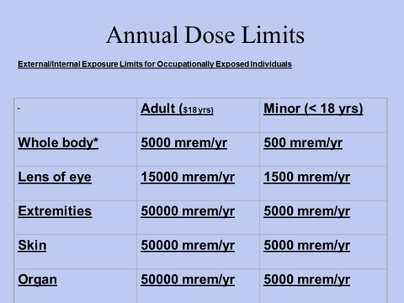
Median Lethal Dose (MLD) is that radiation dose expected to cause death to 50 percent of an exposed population within 30 days (MLD 50/30). Typically, the MLD 50/30 is in the range from 400 to 450 rem (4 to 5 Sieverts) received over a very short period.

