Motors and Controls Name __________________________
Lab 0: Relay and Transformer
Partner __________________________

The schematic diagram below is of the relay you will be using in this lab.

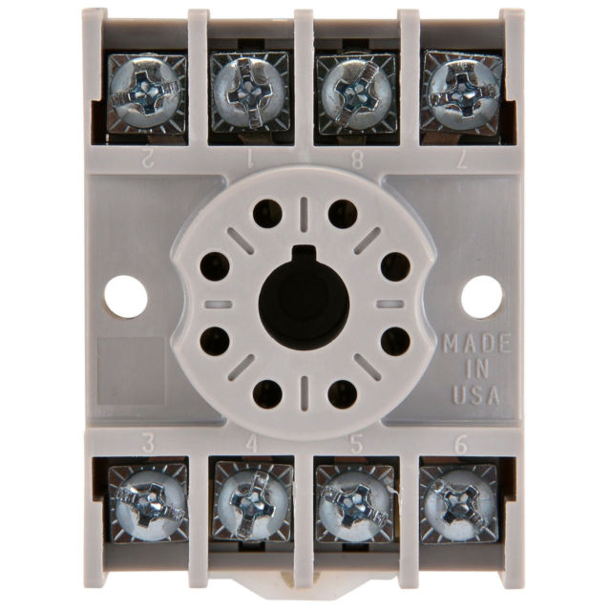
1
5
6
7
4
3
2
8
1
2
7
8
3
4
5
6

(Bottom View)

For each pair of contacts, determine if they are Normally Open (NO) or Normally Closed (NC).

1 and 3: _______ 8 and 5: _______

1 and 4: _______ 8 and 6: _______

Equipment/Parts

Power cord (120 VAC)
Light Switch
120V/24V Transformer
24 VAC Relay
Relay Socket
Connecting Wires
2 Lamps with bases
Wire nuts
DMM

Have your lab instructor supply you with a relay and relay socket. Determine the proper numbering scheme for the socket’s screw terminals based on the schematic diagram on the previous page. Write the correct number for each screw terminal where it belongs in the schematic on the next page.
Initials _______
Once terminal connections are numbered in the schematic, have your work verified:

CR_1
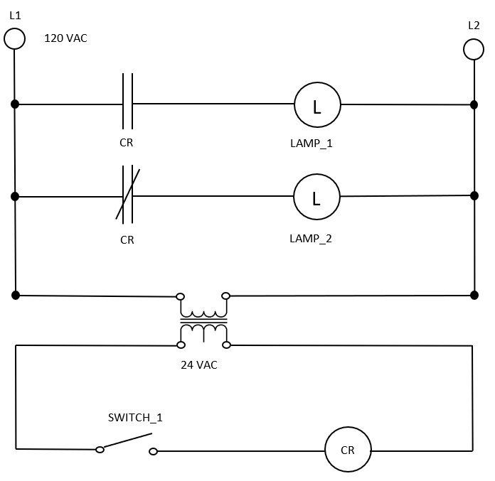
- Measure the resistance of the relay coil. ________

- Measure the resistance of the PRIMARY/SECONDARY transformer coil ____ /____

- Measure the resistance of LAMP_1/LAMP_2 ____ / ____

- Before building your circuits, fill out your voltage estimates in the top row below:
 | Primary Transformer Coil | Secondary Transformer Coil | Relay Coil  (switch on) | LAMP_1  (switch on) | LAMP_2  (switch on)
Estimate (V)
Actual (V)
Current (A)

- Now plug in your system and observe its behavior. With SWITCH_1 ON (circuit energized), measure the actual voltages in the second row of the table above.

- Next, use your measured voltages/resistances to calculate current through each component.

Final verification from instructor that everything is working correctly
Initials _______

- Once done, take it completely apart and have one person put it back together on their own. When you can wire the entire circuit on your own (and have it work correctly) in less than five minutes, you may go.

