Name: ____________________________
Partner: ___________________________

Use the check-off method as you wire the circuit. Alternate with your partner being the one to wire each circuit. Completely disassemble your circuit between exercises to help build your understanding and familiarity with these circuits.
- Look at the schematic diagram below (for #3) and describe how it works. Always be sure to indicate what causes each load to energize or de-energize and what happens when each input is pressed or released.

- Once wired and plugged in, what should (estimate before building) the voltage be:
  - Across the STOP button __________
  - Across the START button __________
  - Across the M contacts __________
  - Across the mag starter coil __________
  - Across the pilot light __________
- Now wire this pilot light START/STOP station. Get your instructor’s initials once it’s working.
Initials
_______
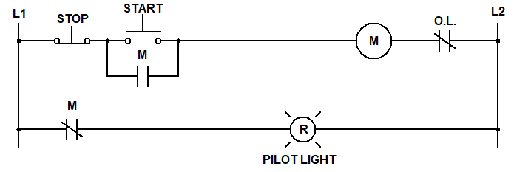

- Once working, measure voltage (no buttons pressed):
  - Across the STOP button __________
  - Across the START button __________
  - Across the M contacts __________
  - Across the mag starter coil __________
  - Across the pilot light __________
- Draw and label a ladder diagram below for a START/STOP station that contains two pilot lights. Lamp_1 comes on only when the motor is running and Lamp_2 only comes on when the motor stops. Wire your circuit using the check-off method and get your instructor’s initials once it’s working.
Initials
_______

