Name: ____________________________
Partner: ___________________________
- Look at the following wiring diagram. Describe (below the diagram) at least two advantages of using a transformer in this circuit.
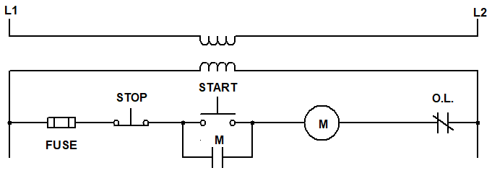

Use the check-off method as you wire. Alternate with your partner being the one to wire each circuit. Completely disassemble your circuit between exercises to help build your understanding.
- For the digram located on the next page (#4), estimate the following voltages when the system is NOT energized. Remember, your estimates only need to be either, zero, source, or ghost. Estimate across:
A. Any STOP button: __________ B. Any START button: __________
C. Mag starter Coil: __________ D. Mag starter contacts: __________
E. Overloads: __________
- For the digram located on the next page (#4), estimate the following voltages when the system IS energized across:
A. Any STOP button: __________ B. Any START button: __________
C. Mag starter Coil: __________ D. Mag starter contacts: __________
E. Overloads: __________

- Wire this multiple START/STOP station. Follow the check-off method and get your instructor’s initials once it’s working.
Initials
_______
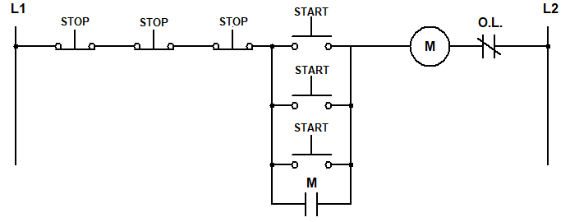

- For the digram above (#4), measure the following voltages when the system is plugged in and NOT energized (no buttons pressed). Remember, measurements should be the exact reading you get (including units) from your meter. Measure across:
A. Any STOP button: __________ B. Any START button: __________
C. Mag starter Coil: __________ D. Mag starter contacts: __________
E. Overloads: __________
- For the digram above (#4), measure the following voltages when the system is plugged in and IS energized by pressting Rung 1 START. Measure across:
A. Any STOP button: __________ B. Any START button: __________
C. Mag starter Coil: __________ D. Mag starter contacts: __________
E. Overloads: __________
- By this point, you should be getting fairly accurate estimates. If you failed to estimate correctly, write why you think this happened in the space below. If all your estimates were correct, write “I’m getting it!” in the space below and give yourself a pat on the back without seeming boastful.

- Look at the diagram below for the following questions. First, explain how this circuit behaves and give an example of where this might be used in industry:
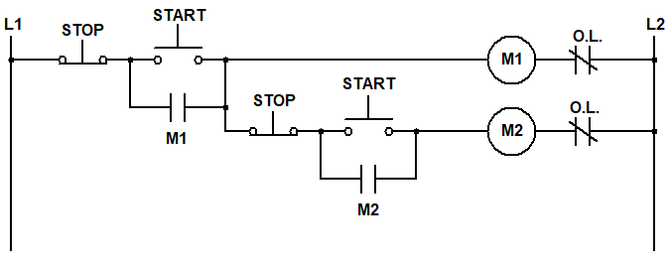
- For the digram located above (#8), estimate the following voltages when the system is NOT energized. Remember, estimates should be the exact reading (including units) that you get from the meter. Estimate across:
A. Rung 1 START: __________ B. Rung 2 START: __________
C. M1 Coil: __________ D. M1 Contacts: __________
E. M2 Coil: __________ F. M2 Contacts: __________
- For the digram located above (#8), measure the following voltages when the Rung 1 START button is pressed. Estimate across:
A. Rung 1 START: __________ B. Rung 2 START: __________
C. M1 Coil: __________ D. M1 Contacts: __________
E. M2 Coil: __________ F. M2 Contacts: __________
- For the digram located above (#8), estimate the following voltages when the Rung 1 START button is pressed, then Rung 2 START button is pressed. Estimate across:
A. Rung 1 START: __________ B. Rung 2 START: __________
C. M1 Coil: __________ D. M1 Contacts: __________
E. M2 Coil: __________ F. M2 Contacts: __________
- When will the coil on M2 de-energize, once running?
- Using the check-off method, wire the diagram from #8. Get your instructor’s initials once it’s working.
Initials
_______

- For the digram located above (#8), measure the following voltages when the system is NOT energized Remember, measurements should be the exact reading you get (including units) from your meter. Measure across:
A. Rung 1 START: __________ B. Rung 2 START: __________
C. M1 Coil: __________ D. M1 Contacts: __________
E. M2 Coil: __________ F. M2 Contacts: __________
- For the digram located above (#8), measure the following voltages when the Rung 1 START button is pressed. measure across:
A. Rung 1 START: __________ B. Rung 2 START: __________
C. M1 Coil: __________ D. M1 Contacts: __________
E. M2 Coil: __________ F. M2 Contacts: __________
- For the digram located above (#8), measure the following voltages when the Rung 1 START button is pressed, then Rung 2 START button is pressed. measure across:
A. Rung 1 START: __________ B. Rung 2 START: __________
C. M1 Coil: __________ D. M1 Contacts: __________
E. M2 Coil: __________ F. M2 Contacts: __________

- What if you had a third motor that needed to be wired in this sequence? NEATLY Draw and label a ladder diagram on a separate page that includes a third motor control (M3). All motors stop when the M1 STOP is pressed. M3 and M2 should stop when the M2 or M1 STOP is pressed. M3 stops when the M3, M2 or M1 STOP is pressed. Each mag starter has an individual start button. Turn this diagram in with your lab work.

- Wire the diagram from #9 using the check-off method. Get your instructor’s initials once it’s working.
Initials
_______
- Practice wiring each of these circuits until it becomes second nature. Any time that remains in the week should be spent watching videos and completing your homework.

