Name: ____________________________
Partner: ___________________________
Use the check-off method as you wire. Alternate with your partner being the one to wire each circuit. Completely disassemble your circuit between exercises to help build your understanding.

Initials
_______
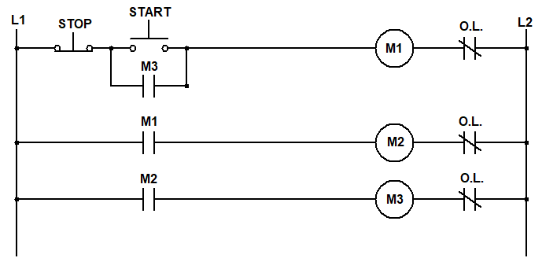
- Wire at the diagram below. Get your instructor’s initials once it’s working.

- In what instance might the circuit above be useful in industry?

- What happens to your energized system when you disconnect the OLs on M2? (Test your theory after answering)

- Below, draw and label a similar schematic, if we needed to run only two motors.

- With the circuit above wired and working correctly:
  - Estimate the voltage across the start button before the system is energized.
  - Estimate the voltage across the contacts on M2 before the system is energized.
  - If the system were energized (press START), what voltage would you expect to see at stop button (not pressed)?
  - If the system were energized (press START), what voltage would you expect to see at stop button (when pressed)?

- With the circuit above wired and working correctly:
  - Measure the voltage across the start button before the system is energized.
  - Measure the voltage across the contacts on M2 before the system is energized.
  - Energize the system (push start). What voltage do you measure across the stop button (not pressed)?
  - Energize the system (push start). What voltage do you measure across the stop button (when pressed)?

- NEATLY Draw and label a ladder diagram below for a circuit that contains two motors and two START/STOP buttons. Both mag starters energize when either START button is pushed. Pressing either STOP button, or if either set of overloads goes out, both mag starters de-energize. Contacts from both mag starters must be used for latching. Get initials prior to building.
Initials
_______

- Wire your diagram and show your instructor that it’s working.
Initials
_______
- Test your system by disconnecting one set of overloads, while it is energized. Did both mag starters stop?
- Looking at the diagram below, describe the operation of this motor control circuit.

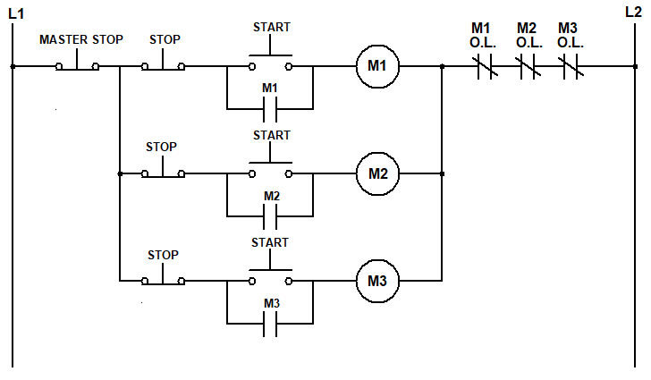

- In what instance might the circuit above be useful in industry?

Initials
_______
- Wire the diagram above. Get your instructor’s initials once it’s working.
- If all three motors are running and the overloads for M2 trip, what happens to Motor 1?

- This system is running in your process. You receive a call because M2 stopped in the middle of a production run. The motors controlled by M1 and M3 are both operating as expected. When you measure across the M2 coil, you get a voltage reading of 17V. You get a similar number when measuring across both the M2 contacts and the START button. Where’s the problem?

- This system was moved from one side of your plant to the other. Facilities finished hooking it up, and everything seems to be running okay until the operators try the MASTER STOP. When pressed, both M1 and M2 coils de-energize, but the M3 coil does not, and the associated motor can only be stopped by pressing the STOP button on M3 rung. What do you think happened?

- The circuit breaker for the motor control circuit trips. You disconnect the coil for M1 and measure 1.5Ω. You’re not sure if that’s a good number. What two meathods might you use to verify that is the correct resistance?

- Below, draw and lable a schematic for a reversing magnetic motor starter using both mechanical and electrical interlocks in both forward and reverse.

