Name: ____________________________
Partner: ___________________________

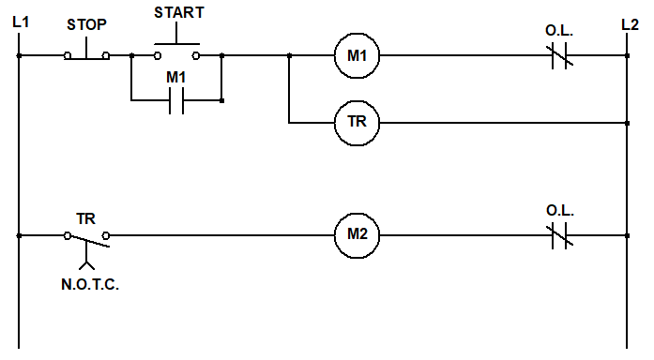
- Look at the wiring diagram below. Explain in a sentence or two how you expect the circuit to behave.

- Wire the timing START/STOP station above. Follow the check-off method and get your instructor’s initials once it’s working.
Initials
_______

- Wire the Jog START/STOP station below. Follow the check-off method and get your instructor’s initials once it’s working.
Initials
_______

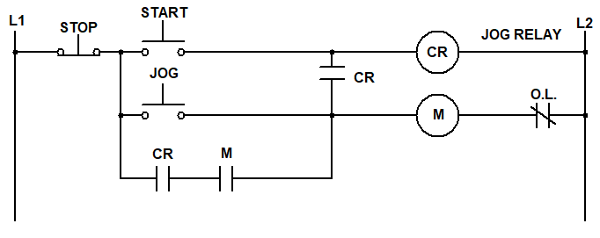

- Design a different run/jog circuit of your own design and draw it below.

- Wire your run/jog circuit. Follow the check-off method and get your instructor’s initials once it’s working.
Initials
_______

