Name: ____________________________
Partner: ___________________________
- Looking at the wiring diagram below. Explain in a sentence or two how you expect the circuit to behave.
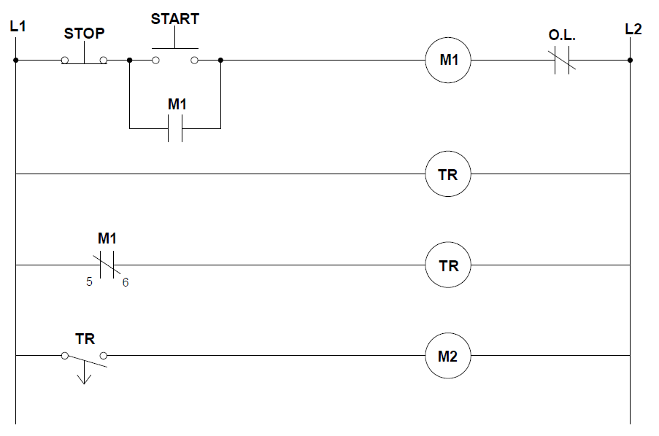

- Before wiring the circuit, answer the following questions from the diagram:
  - What is the resistance across the M1 coil? _____________
  - What is the resistance across TR points 2 and 10? _____________
  - What is the resistance across TR points 5 and 6? _____________
  - When plugged in (and no buttons pushed), what will be the voltage across:
    - Stop PB? _____________
    - Start PB? _____________
    - M1 contacts? _____________
    - M1 coil? _____________
    - M2 coil? _____________
  - After pushing the Start button, what will be the voltages across:
    - Stop PB? _____________
    - Start PB? _____________
    - M1 contacts? _____________
    - M1 coil? _____________
    - M2 coil? _____________

- Wire the timing START/STOP station from #1. Follow the check-off method and get your instructor’s initials once it’s working.
Initials
_______

- Now that the circuit is wired, answer the following questions by taking measurements:
  - When plugged in (and no buttons pushed), what is the voltage across:
    - Stop PB? _____________
    - Start PB? _____________
    - M1 contacts (rung 2)? _____________
    - M1 coil? _____________
    - M2 coil? _____________
  - After pushing (and releasing) the Start button, what is the voltages across:
    - Stop PB? _____________
    - Start PB? _____________
    - M1 contacts (rung 2)? _____________
    - M1 coil? _____________
    - M2 coil? _____________
Go back and look at your estimates on the previous page. If you failed to estimate correctly, try to determine why. You should know the voltage to expect before taking ANY voltage measurements.

- Suppose you used a set of normally closed contacts for your Off-delay timer, rather than the normally open. How would that change the behavior?

Initials
_______

- Wire your new circuit (this should only involve moving one wire) and get your instructor’s initials once it’s working.
- Locate the eight capacitors and find the capacitance of each. Also see if you can determine from the markings if the capacitor is good or bad.

Expected Actual Good/Bad
  - ________ to _________ ______________ ______________
  - ________ to _________ ______________ ______________
  - ________ to _________ ______________ ______________
  - ________ to _________ ______________ ______________
  - ________ to _________ ______________ ______________
  - ________ to _________ ______________ ______________
  - ________ to _________ ______________ ______________
  - ________ to _________ ______________ ______________

- Find the following information on motors A, B, and C:
 | Motor A | Motor B | Motor C
Low Voltage
High Voltage
Horse Power
Amps
Phase
Frequency
RPM
Duty Cycle
Service Factor
KVA Code
Bearing Type (shaft)
Bearing Type (opp)
- Test Motor D using resistance to verify the windings are not damaged.

Resistance Good/Bad
  - T1 to T4: _________ _________

  - T1/T4 to T2/T5/T3/T6: _________ _________

  - T2 to T5: _________ _________

  - T2/T5 to T1/T4/T3/T6: _________ _________

  - T3 to T6: _________ _________

  - T3/T6 to T1/T4/T2/T5: _________ _________

  - T7 to T8: _________ _________

  - T8 to T9: _________ _________

  - T9 to T7: _________ _________

  - T7/T8/T9 to T1-T6: _________ _________

  - T1 – T9 to frame: _________ _________

- Wire a 3-phase motor for 230VAC 3-phase power using a simple Start/Stop station. Get your instructor’s initials once it’s working.
Initials
_______

