6.

Tools and Tasks
Anonymous
#argument, #reportinginformation, #currentevents, #systemanalysis, #ethos, #kairos, #logos, #sharedvalues, #technology, #automotives, #finances #intellectualproperty

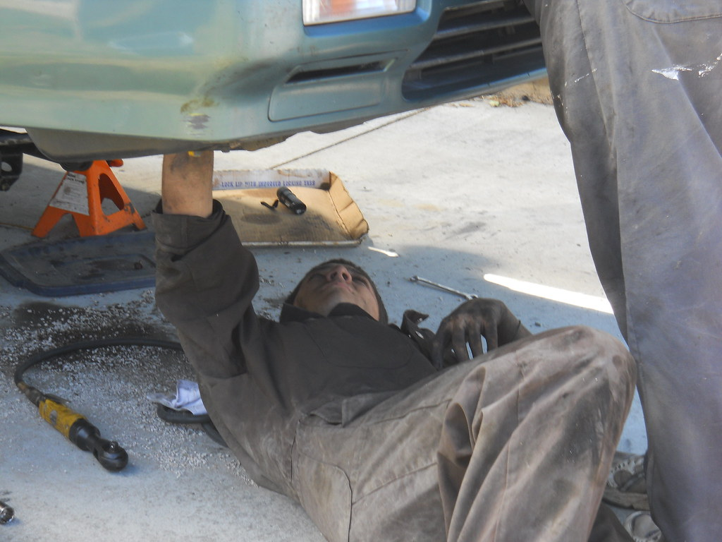
"Andrews clutch job" by Bob n Renee is licensed under CC BY 2.0
My town is losing a car repair shop. The gas station at the end of Main Street will continue to sell gas, but the garage attached to it is going to close. The mechanic, who has been there for twenty-five years, will have to find work elsewhere. He had a loyal following; a friend told me he once opened early on a Sunday to fix her tire.
The garage isn’t closing for lack of customers. Nor is it closing because of taxes, that ritual demon of the political Right. A major reason, the owner said, is technology, and the way manufacturers are making cars so complex. To fix them requires sophisticated computers that a small shop can’t afford. “There isn’t a car from the ’70s or ’80s that we can’t work on,” the owner told our local weekly. “But we’re not in the position to make the investment in all the electronics and computers. To make that transition would be cost prohibitive.”
He’s not the only one. Independent repair shops are going out of business all over the country. In California, more than half the gas stations had repair shops as recently as ten years ago. Now about 15% of them do. Part of that is because oil companies are forcing out independent owners and taking over the retail end themselves. (Have you noticed that prices are rising?) But partly too it’s because the local shops can’t repair the new computerized cars.
This is a trend that bears more scrutiny than it has received. It goes to two of the central narratives of our economy — the conventional version at least. One is that virtue and hard work prevail, which in this case is not the case. Hard work and virtue have succumbed to corporate contrivance. You are shocked?
The other narrative is the one that casts technology as Savior. The word itself has become practically a synonym for “future.” Computers are portrayed as the ultimate instruments of democracy. They will put knowledge — and therefore power — on every desktop. They will cause hierarchies and bureaucracies to crumble. Every man and woman will be a king. “While the Industrial Revolution herded people into gigantic social institutions — big corporations, big unions, big governments,” wrote Newt Gingrich in his book To Renew America, “the Information Revolution is breaking up these giants and leading us back to something that is — strangely enough — much more like de Tocqueville’s 1830s America.”
Brother Newton is a busy man, and maybe he just didn’t have time to consider the complications. For one thing, there’s the matter of agency. As David Noble observed in his book Forces of Production, technology is not an impersonal force. It does not have an inevitable evolutionary path. Technology is a projection of those who make it, including corporate interests and proprietary claims. This can lead to a lot of trouble.
Noble looks in particular at the machine tool industry, and how it evolved to enable top-down management control instead of autonomy on the shop floor. The technology could have gone either way; it was the corporate managers who made the call. Computers have followed a similar pattern. Potentially they can liberate the desktop, and sometimes do. But in practice they often do the opposite. Now the boss can monitor your every keystroke. At home corporations can plant little spies on your machine. The Feds can track your personal e-mail exchanges. You think the Department of Homeland Security might have a computer or two?
And so with the technology built into cars. It would seem possible to design it in a way that made cars simpler and less expensive to repair. I don’t really know, but it does seem reasonable. The problem is, would it fit the business plans of the corporations that make the cars? Why would General Motors want to put more capacity and control into the hands of independent garages like the one in my town? Wouldn’t it want to lock a customer into its own repair and dealer network, much the way computer printer manufacturers try to lock us into their expensive cartridges?
That seems to be what’s happening. Car repair used to be a knowledge commons, shared in driveways, urban curbsides, and voc. ed. classes. Get yourself some tools and you were ready to go for most routine repairs. The machines were open to the eye. There was little if any secret and proprietary code. Repair manuals could help with the more technical issues, but you’d probably go to a shop for those anyway.
Today, by contrast, high-tech is turning cars into black boxes, a little like Microsoft Windows. Mechanics need fancy diagnostic tools, and the auto companies know that independent shops can’t afford them, let alone back yard tinkerers. That leaves dealers. I’m sure that some are good and honorable. But if someone out there has found dealers more reliable and economical than independent repair shops, would they please let us know? Last time I checked, the dealer would charge about 30%-50% more for repairs to my car; and they usually manage to find a few extra things to fix. (I’ll spare you my dealer stories, today at least.)
This is not the Every-One-Of-Us-A-King scenario of which Mr. Gingrich waxed so enthusiastic. It looks more like one of his “gigantic social institutions” using technology and intellectual property to reassert a claim. Like the common fields and forests of 18th century England, the knowledge commons of car repair is being fenced and locked. The same is happening in other realms of the Information Age, such as genetically modified seeds. (Technology that serves an urgent need such as fuel economy might get a pass, provided it is designed to be as open as possible.)
People like Newt — and there are lots of them — don’t consider how proprietary interest can warp the vectors of technology, and turn it to its own ends. They ignore also the ambiguous relationship between technology and well-being. More sophisticated and complex does not always mean better. To the contrary, as technology becomes more “advanced,” we who rely on it can become more helpless and dumb. My father took apart his first Model T — or maybe it was a Model A — and put it back together again. He took apart radios and toasters and fans and fixed them too. My son won’t be able to do any of that, even if he is so inclined.
Is this progress or regress? Does progress reside in the thing or in the user of the thing? Which is more “advanced”: the technology that enables the user to fix the car herself, or the one that renders us helpless in the face of the black box? My wife grew up in a Third World country, and her father built their bamboo house with rusty old hand tools that could have been left over from a garage sale in the U.S. He started with a stand of trees and finished with a house. By contrast, when we moved into our current residence we just unloaded a truck. Who is more advanced, us or him? Which child is more advanced: the one who can make up games with a ball on a city sidewalk or the one that needs expensive video games to be amused?
I wonder if it is entirely coincidental that as technology has “progressed” in the industrial and post industrial world, those subject to it have become more disconnected and depressed and less able to control their own impulses and moods. (Then we become yet more dependent on technology — in the form of pharmaceutical concoctions — for relief.) One evening after dinner my wife looked up from the paper and said, “What’s this word I keep seeing here — depression?” As a child she had no electricity, no television. Is there a connection?
I am not suggesting that we all go back to bamboo huts, though a few weeks might not be the worst thing now and then. I am just questioning the techno-romantics who think technology by its very nature is enlarging and fulfilling. Sometimes it does the opposite, and hollows us out. Adam Smith actually had a glimmer of this, regarding the effect of the division of labor upon the workers involved. As each task becomes more specialized, Smith noted, it engages less of the person. Narrow work leads to human atrophy; it can make people “as stupid and ignorant as it is possible for a human creature to become.” (Smith had a brooding cautionary side that is lacking among his acolytes today.)
What’s happening now is bigger and more endemic. It affects people not just as employees but as “consumers” even more (and consumption is the real work of our “economy” to begin with.) This is a big topic, obviously, but a lot goes back to who is devising the technology and why. Open technologies and open systems are less inclined to the unvirtuous cycle than closed ones are. There’s a built-in social dimension that engages us at more levels, as producers as well as just consumers. Open systems evolve to serve the needs of users rather than of those who seek to use the users for their own ends. Compare, for example, traditional fairy tales with the kiddy entertainment today that has embedded products such as candy bars and colas.
When someone finally writes the sequel to The Wealth of Nations, open systems and decentralized technologies will be, I think, a central theme. Perhaps a working title could be From the Wealth of Nations to the Well-Being of the People Involved.
___________________

Tools and Tasks is licensed under a Creative Commons Attribution-ShareAlike 4.0 International License. It was previously published on onthecommons.org.

