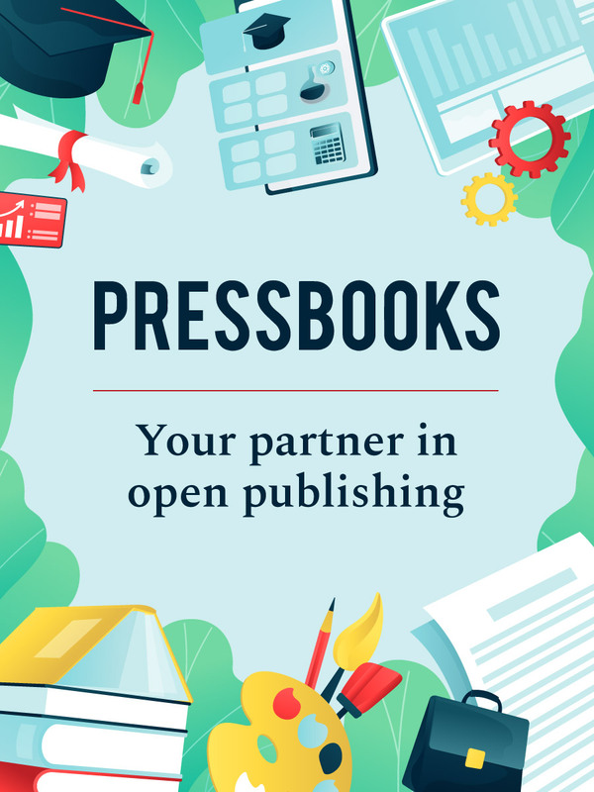

Doing the Work: Diversity, Equity, and Inclusion in Open Educational Resources

Doing the Work: Diversity, Equity, and Inclusion in Open Educational Resources

Heather Blicher; Abbey Gaterud; Valencia Scott; Veronica Vold; Michaela Willi Hooper; and Stephanie Lenox

Doing the Work: Diversity, Equity, and Inclusion in Open Educational Resources Copyright © by Heather Blicher; Abbey Gaterud; Valencia Scott; Veronica Vold; Michaela Willi Hooper; and Stephanie Lenox. All Rights Reserved.

Contents
- Introduction
- Module 1: Introduction to DEI in Targeted Pathways
- 1.1 Overview
Heather Blicher and Valencia Scott
- 1.2 Diversity, Equity, and Inclusion
Heather Blicher and Valencia Scott
- 1.3 Finding Your Lens: Language, Theory, and Equity
Heather Blicher and Valencia Scott
- 1.4 Writing Textbooks with an Equity Lens
Heather Blicher and Valencia Scott
- 1.5 Apply and Submit
Heather Blicher and Valencia Scott
- Module 2: Inclusive Textbook Revision
- 2.1 Overview
Stephanie Lenox and Abbey Gaterud
- 2.2 What Revision Is and Is Not
Stephanie Lenox and Abbey Gaterud
- 2.3 The Revising Mindset
Stephanie Lenox and Abbey Gaterud
- 2.4 The Work: Revising for Inclusion
Stephanie Lenox and Abbey Gaterud
- 2.5 Principles for Inclusive Revision
Stephanie Lenox
- 2.6 Applying Inclusive Language
Stephanie Lenox
- 2.7 Apply and Submit
Stephanie Lenox and Abbey Gaterud
- Module 3: Working Toward Accessibility: Expanding Your Universe of Learners
- 3.1 Overview
Veronica Vold
- 3.2 What are Figure Captions, Alt Text, and Image Descriptions?
Veronica Vold
- 3.3 Writing Figure Captions, Alt Text, and Image Descriptions
Veronica Vold
- 3.4 What are Descriptive Links?
Veronica Vold
- 3.5 Media Captions and Transcripts
Veronica Vold
- 3.6 Apply and Submit
Veronica Vold
- Module 4: Building OER Together for All: Attributions, Access, and Authorship
- 4.1 Overview
Michaela Willi Hooper
- 4.2 How Copyright Laws Created the Need for Open Licensing
Michaela Willi Hooper and Marco Seiferle-Valencia
- 4.3 The Public Domain and Why Remixing Matters
Michaela Willi Hooper
- 4.4 Open Licenses: Creative Commons and Beyond
Michaela Willi Hooper
- 4.5 Attributions: Giving Credit
Michaela Willi Hooper
- 4.6 Apply and Submit
Michaela Willi Hooper
- Module 5: Equity-Minded Course Revision
- Appendix

1
Welcome to the Doing the Work: Diversity, Equity, and Inclusion in Open Educational Resources!

Course Outcomes
- Recognize how DEI intersects with every aspect of this project and OER.
- Describe the value of DEI for authors and students.
- Realize the potential to create a curriculum that is both antiracist and inclusive of multiple intersecting human experiences.
- Develop the courage and humility necessary to reassess one’s own perspective.
- Practice using tools and strategies to promote equity in textbook and course design.

About this Course:
This training is designed to orient Revising Authors to the skills and strategies necessary to meet our Targeted Pathways equity-minded outputs: student-centered textbooks that fully integrate with dynamic courses. This training includes five modules of asynchronous content that supports authors in the revising stage of the Targeted Pathways project. Each module builds toward a synchronous learning opportunity to join with fellow Revising Authors to assess skills and knowledge of concepts.
To orient to the Revising Author Role & Responsibilities, please visit the following:
- Revising Author Role & Responsibilities [Google Doc]: This document provides context for the role of the Revising Author as well as a description of the responsibilities and deliverables.
- Blogpost about Targeted Pathways [Blogpost]: This blogpost provides an update on the Targeted Pathways Project as of March 2023.

Equity Statement
The Open Oregon Educational Resources Targeted Pathways Project seeks to dismantle structures of power and oppression entrenched in barriers to course material access. We provide tools and resources to make diversity, equity, and inclusion (DEI) primary considerations when faculty choose, adapt, and create course materials. In promoting DEI, our project is committed to:
- Ensuring diversity of representation within our team and the materials we distribute
- Publishing materials that use accessible, clear language for our target audience
- Sharing course materials that directly address and interrogate systems of oppression, equipping students and educators with the knowledge to do the same
Designing and piloting openly licensed, intersectional, and antiracist course materials is one starting point among many when addressing inequities in higher education. Our project invites students and educators to engage with us in this work, and we value spaces where learning communities can grow and engage together.
We welcome being held accountable to this statement and will respond to feedback submitted via our contact page [Website].

Course Timeline and Activities
Revising Authors complete one module per week (except for Module 2, which takes two weeks due to spring break). To complete a module, you will:
- read all the content in the module
- optionally attend a zoom workshop meeting
- complete the Apply and Submit activity for the module
- review feedback from the facilitators on the Apply and Submit activity

Accessibility Statement
Doing the Work was created with a good faith effort to ensure that it will meet accessibility standards wherever possible, and to highlight areas where we know there is work to do. It is our hope that by being transparent in this way, we can begin the process of making sure accessibility is top of mind for all authors, adopters, students and contributors of all kinds on open textbook projects.
There are known issues and potential barriers to accessibility in this version of Doing the Work. When we revise and publish this Pressbook in the next phase of this project, these issues will be addressed. If you encounter an accessibility issue that you need fixed, please email Phoebe Daurio at dauriop@linnbenton.edu.

Licenses and Attributions

Open Content, original
“Introduction” by Heather Blicher, Phoebe Daurio, Valencia Scott, and Veronica Vold for Open Oregon Educational Resources [Website] is licensed CC BY 4.0.

I

Module 1: Introduction to DEI in Targeted Pathways
Click on the + in the Contents menu to see all the parts of this chapter, or go through them in order by clicking Next → below

1.1 Overview
Heather Blicher and Valencia Scott

Learning Objectives
- Recognize the author’s DEI role
  - Approach your work with an equity lens
  - Define Diversity, Equity, and Inclusion
  - Recognize the difference between equity and equality
  - Identify the importance and benefits of DEI

- Articulate the importance of being an antiracist writer and addressing citation diversity
  - Recognize managing writing anxiety as a strategy for antiracist writing
  - Challenge assumptions of DEI standards from trusted resources
  - Describe what it means to write for a diverse audience
  - Engage in critical race theory

- Analyze the nature of language as powerful and always changing
  - Become familiar with the Leadership Style Sheet and apply the Word List to your writing as an antiracist writing strategy
  - Identify appropriate terminology (gender/sex, race/ethnicity terms, etc.)

- Recognize that writing textbooks with an equity lens is labor-intensive work
  - Critically analyze the work that you are writing with humility to reassess your perspective

Over the last year, the Targeted Pathways Project has worked to develop OER textbooks covering Human Development and Family Studies (HDFS), Sociology, and Criminal Justice. Each of these subjects engage a range of social issues that affect communities across the country. Our goal is to ensure that the information in our textbooks is as diverse as the students and instructors who will eventually use our resources. When creating and revising these resources, it is important for us to be intentional about the language we use in our textbooks, challenging our own biases and assumptions as authors, and ensuring that historically marginalized voices are centered. This means that we don’t shy away from histories of inequality and injustice and that we actively work to cite the work of people of color. To achieve this, we need to engage with an equity lens to guide our curriculum and course design.

So what is an equity lens?
Ida B. Wells, a Black journalist, activist, and researcher, in the late 19th and early 20th centuries, said, “The way to right wrongs is to turn the light of truth upon them.” Leading with an equity lens in curriculum design means shining a light on underrepresented perspectives, centering them, and diving deeper into the histories of systemic oppression that lead to social injustices and disparities we live with today.

Licenses and Attributions

Open Content, original
“Overview” by Heather Blicher and Valencia Scott for Open Oregon Educational Resources [Website] is licensed CC BY 4.0.
References
Wells-Barnett I. B. Bay M. & Gates H. L. (2014). The light of truth: writings of an anti-lynching crusader. Penguin Books.

1.2 Diversity, Equity, and Inclusion
Heather Blicher and Valencia Scott

What is DEI?
This acronym and other versions of it are often used, but not always defined.
Diversityis the variety of characteristics that make individuals unique, including race, gender, age, ethnicity, sexual orientation, body size, abilities, and many others.
Equity is the fair treatment, access, opportunity, and advancement for all individuals, while at the same time striving to identify and eliminate barriers that have prevented the full participation of marginalized groups of people.
Inclusion refers to creating a culture where everyone feels a sense of belonging and is valued for their unique perspectives and contributions.

Together, diversity, equity, and inclusion are a set of principles that are intended to create a more inclusive and equitable society by valuing and leveraging the differences between people. These three principles are often used together to create a more inclusive and equitable educational environment and/or institution, workplace, or community.

What is the difference between equality and equity?
Equality and equity are similar in that they both aim to promote fairness and justice for all individuals, but they approach this goal in different ways.
Equality is about treating everyone the same, regardless of their individual differences or needs. This approach assumes that everyone starts from the same place and has the same opportunities, so if everyone is given the same resources and support, it is assumed they will all achieve the same outcomes.
Equity recognizes that individuals have different needs and starts from the understanding that not everyone has the same advantages or opportunities. It aims to level the playing field by providing resources and support in a way that addresses these individual differences and needs.
One or more interactive elements has been excluded from this version of the text. You can view them online here: https://openoregon.pressbooks.pub/dothework/?p=45#oembed-1

Why are we focused on equity?
Diversity cannot be separated from equity, and equity is vital to sustainable inclusion: Equity is the bridge between institutional representation and institutional action.
The driving rationale behind DEI frameworks:
- Representation of intersectional identities (e.g. race/ethnicity, gender/gender expression, sexuality, religion, ability, and socioeconomic background – among many others)
- Acknowledgment of social inequalities and power dynamics which have led to historically exclusive practices and structural inequities within higher education
- Introspective analysis of an organization’s complicity in/perpetuation of social disparities and reframing institutional culture, structures, and thinking to rectify inequities specific to the organization
An example of the difference between equality and equity is in education: equality in education would mean that every student is given the textbook, while equity in education would mean that each student is given the textbook and any resources they need to succeed, such as providing accommodations for students with disabilities.
In short, equality is treating everyone the same, equity is treating everyone fairly.

Self Check

An interactive H5P element has been excluded from this version of the text. You can view it online here: https://openoregon.pressbooks.pub/dothework/?p=45#h5p-3

Further Reading
MPH@GW, the George Washington University Online Master of Public Health program. (2022). Equity vs. equality: what’s the difference? https://onlinepublichealth.gwu.edu/resources/equity-vs-equality/
Pike, U. (2019). Taking OER off-campus: equity is about more than saving money. CCCOER Blog: Equity and Openness: Perspectives from North American Colleges and Universities. https://www.cccoer.org/2018/10/09/on-equity-diversity-inclusion-and-open-education/
U.S. Department of Education (n.d.). Department of education equity action plan. https://www.ed.gov/equity
West, Q. (2019). Overview of EDI and open education. CCCOER Blog: Equity and Openness: Perspectives from North American Colleges and Universities. https://www.cccoer.org/2018/10/09/on-equity-diversity-inclusion-and-open-education/

Licenses and Attributions

Open Content, original
“Diversity, Equity, and Inclusion” by Heather Blicher and Valencia Scott for Open Oregon Educational Resources [Website] is licensed CC BY 4.0.

1

1.3 Finding Your Lens: Language, Theory, and Equity
Heather Blicher and Valencia Scott

Language & Theory: What’s the Big Deal?
You may have seen recent articles in the media or debates on the news about language use in education, especially when it comes to topics like DEIor Critical Race Theory. You may have heard heated debates around these topics on the news, in your classrooms, or even in your day-to-day personal interactions. In general, much of the pushback on these topics stems from white supremacy, structural racism, and resistance to interrogating the history of oppression and inequality in the United States.
These are hot-button topics for a reason. Language has power, and the terms that we use when talking about race, ethnicity, gender, sexuality, and religion are rarely benign. Think about the last time you read an offensive news headline, overheard an insensitive slur being used in a conversation, or came across a derogatory term in one of your own textbooks. You may have been taken aback by the thoughtlessness of those words. You may have felt especially offended, frustrated, or demoralized if those words were referring to a part of your identity or lived experience. When you reflect on that moment, what comes up for you? Now take a moment to reflect on how students may feel every time they open up a textbook or enter a lecture where their community, identity, or lived experience are described in derogatory ways.
As an author, writing for DEI is about writing from a place of awareness: you’re taking a critical look at our society, engaging histories of oppression, and challenging students and educators to have real conversations about these social inequalities.

The Power of Words
Language is a vehicle of expression, and the way we ascribe meaning to certain terms can either empower or disempower our students. One way we can begin to understand the importance of word choice in our textbooks is to think about power. In DEI, we talk a lot about power dynamics when it comes to topics like systems of oppression, privilege, white supremacy, and structural racism. But the common thread that weaves these topics together are the words that have been used to justify these systems and enforce the marginalization of certain groups.
As an author, you have the ability to write a textbook that will direct or influence the thoughts and behaviors of students in the classroom. That’s a lot of power. As an author, you’re also writing a textbook that includes your research and perspective on topics like sociology, criminal justice, and Human Development. Your perspectives will inevitably touch on the lived experiences of many students who will use this book during one of their courses. As an author you have a choice: Do you want to use status quo language that may be marginalizing and non-inclusive? Or do you want to empower students to think critically by doing the same, and using terminology that is accurate and reflects the true histories of diverse identities and experiences?
Power [noun]
The ability to do something or act in a particular way, especially as a faculty or quality.
The capacity or ability to direct or influence the behavior of others or the course of events.

Historically, the system of higher education has been white-dominated and male-centric. People in positions of educational power historically ascribed words to identities and lived experiences that perpetuated stereotypes and degraded certain identities under the guise of academia. Words like ‘colored,’ ‘homosexual,’ and ‘illegal’ were once a regular part of the educational curriculum. Aside from being offensive and discriminatory, this kind of language has also had far-reaching political effects too. Think about the last time you watched a controversial political speech or news debate and heard these words. It’s important to remember that the power of language goes beyond educational settings: they shape the way we are told to think about others, can reinforce implicit bias, and have harmful social effects when used by people in positions of power. As authors, it’s important to unpack the relationship between power, white supremacy, and language in education so that you can better understand how to approach word choice in your textbook. As a writer, you are in a unique position to publish a textbook that a diverse range of students or educators will use. What impact do you want your textbook to leave in the classroom?

How do I find the ‘Right’ Words?
Sometimes we feel anxious or uneasy talking about issues of race, white supremacy, and marginalization. It’s easy to get distracted and focus all that uneasiness onto finding the ‘right’ word. But sometimes our attempts to be hypersensitive to language can actually distract us from the real critical thinking that goes into writing for DEI. Sometimes we channel the unease and discomfort in writing on these topics by hyper-focusing on word choices. This can be unproductive because you are focusing more on finding the right word, and less on writing as an antiracist.
It’s important to remember that language use isn’t about ‘political correctness.’ It’s about thinking critically and reflecting on how our word choice can either dismiss, degrade, or stereotype people. So what are the ‘right’ words to use when writing for Diversity, Equity, and Inclusion? Unfortunately, there’s no simple answer to that question. It may be frustrating to realize that there is no ‘right’ word to use at any given time because the language of DEI is constantly changing and evolving. That doesn’t mean there aren’t words that are completely offensive and wrong (think back to some of the examples listed under the Power of Words section), but it’s important to understand that it’s not just about word choice – it’s about your mindset. Let’s go through a quick example to help you better understand. Take a look at the passages below from a textbook called ‘Mexican American Heritage’:

What elements of these passages do you find problematic? What would you do if you came across a passage like this in one of your own textbooks?
- Passage 1: “[Industrialists] were used to their workers putting in a full day’s work, quietly and obediently, and respecting rules, authority, and property. In contrast, Mexican laborers were not reared to put in a full day’s work so vigorously. …There was a cultural attitude of ‘mañana,’ or ‘tomorrow,’ when it came to high-gear production. It was also traditional to skip work on Mondays, and drinking on the job could be a problem.” (Seidman)
- Passage 2: “The Atlantic Slave Trade between the 1500s-1800s brought millions of workers from Africa to the southern United States to work on agricultural plantations” (McGraw Hill)
While you may not see any outright slurs in the above passages, the language and tone still use racial epithets that are derogatory and stereotypical. How? Think about what impression a student may get from these passages:
Passage 1 – Stereotypes: This passage is an example is an example of harmful language. The word choice perpetuates offensive stereotypesof Mexican culture as drunk, lazy, and irresponsible.
An interactive H5P element has been excluded from this version of the text. You can view it online here:
https://openoregon.pressbooks.pub/dothework/?p=189#h5p-8

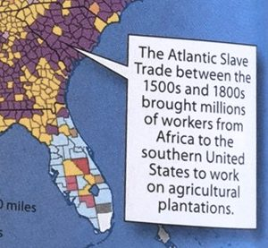

Passage 2 – Omission: This passage is an example of intentional language misuse – often called ‘whitewashing.’ Rather than writing “The Atlantic Slave Trade between the 1500s-1800s trafficked millions of enslaved African people to the southern United States to force them to work on agricultural plantations,” authors opt for ‘lighter’ terminology.
An interactive H5P element has been excluded from this version of the text. You can view it online here:
https://openoregon.pressbooks.pub/dothework/?p=189#h5p-9

Reflection: Imagine being a student who is reading this passage.
- Think about how disempowering and degrading it would be to read a textbook that omits lived experiences with oppression and/or reduces aspects of your history, culture, and identity to the stereotypes you see in the passage above. Reflect on the kind of discussions that may come out of reading this passage. How do you think this would affect the student’s experience in the classroom?

- Imagine being a student who is learning about Mexican American/African American for the first time, and being told by an instructor that this is factual information. Take a minute to reflect on how this may contribute to reinforcing or developing a student’s implicit bias.

Tackling Theory: Where Do I Start?
We’ve spent this past section talking about the power of words and the legacy of harmful language in education. As an author, you have a responsibility to strike a balance between accurate terminology and inclusive language. That can be tough, especially when many of the terminologies used in the past are offensive and derogatory. You may be wondering how to practically apply these skills to your textbook. One way to both inform your mindset and the content of your textbook is to use social theory frameworks (Seidman 2016). Remember, the language and word choice of your textbook is important – but if you are in the mindset of an antiracist and intersectional writer, the language will follow.
To start, social theories are frameworks used in social science and humanities disciplines to analyze, explain, and understand social structures, power dynamics, and cultural norms. There are many social theories and schools of thought to choose from, but we’ll focus on two that are the backbone of your equity lense: Critical Race Theory and Intersectionality.
Critical Race Theory (CRT) and Intersectionality are contemporary social theories that highlight how power structures in the United States privilege and disadvantage people in our society. CRT was developed by Derrick Bell, Kimberlé Crenshaw, and Richard Delgado. As scholars in the legal field, Bell, Crenshaw, and Delgado sought to underscore the role of race and racism embedded in the political, social, and economic structures of the United States. Since the 1970s, CRT has been critical in shaping the framework and has played a significant role in academic scholarship about race, racism, and racial inequality. What makes CRT unique is its emphasis on both theory and practice:
“Crenshaw—who coined the term “CRT”—notes that CRT is not a noun, but a verb. It cannot be confined to a static and narrow definition but is considered to be an evolving and malleable practice. It critiques how the social construction of race and institutionalized racism perpetuate a racial caste system that relegates people of color to the bottom tiers. CRT also recognizes that race intersects with other identities, including sexuality, gender identity, and others. CRT recognizes that racism is not a bygone relic of the past. Instead, it acknowledges that the legacy of slavery, segregation, and the imposition of second-class citizenship on Black Americans and other people of color continue to permeate the social fabric of this nation” (ABA 2021).

Critical Race Theory
“CRT is not a diversity and inclusion ‘training’ but a practice of interrogating the role of race and racism in society that emerged in the legal academy and spread to other fields of scholarship.” (ABA 2021)
If the concept of an equity lens feels abstract to you, think about CRT as one way to concretely apply that lens to your textbook and guide your practical work as a writer/educator. CRT is one of many ways to approach discussions about power, structural inequality, and social change. While CRT emphasizes race, your textbook will undoubtedly include topics related to gender, sexuality, religion, disability, and more. This is where intersectionality becomes important.
Intersectionality was first coined in 1989 by legal scholar and civil rights advocate, Kimberlé Crenshaw. Crenshaw originally used the term in a paper for the University of Chicago Legal Forum which emphasized the compounding marginalization faced by African American Women in education. Crenshaw highlighted the importance of centering the experience of African American women at the intersection of both racism and sexism (hence the term: intersectionality). Though intersectionality started as a legal theory, over three decades later, scholars have applied Crenshaw’s theory of intersectionality to a range of issues like gender, class, and disability.

Intersectionality
“Intersectionality is a lens through which you can see where power comes and collides, where it interlocks and intersects. It’s not simply that there’s a race problem here, a gender problem here, and a class or LBGTQ problem there. Many times that framework erases what happens to people who are subject to all of these things.” (Crenshaw 2017)
While intersectionality is a crucial component of your equity lens, it’s important to note that it’s not a “grand theory of everything” (Crenshaw 2017). Intersectionality is your starting point for understanding why equity is important: we all hold multiple identities, and each of those identities can contribute to unique, varying experiences with inequality and oppression.
One theory doesn’t fit all, but you should consider CRT and intersectionality as a starting point to help you expand the anti-oppressive and antiracist frameworks you use in your writing. As you learn to apply an equity lens to your textbook content, remember that this is all a part of the bigger picture of DEI.
When thinking about the kind of theories you want to employ in your text, you can use these 4 questions to guide your thought process:
- Are intersectional identities represented? (e.g. race/ethnicity, gender/gender expression, sexuality, religion, ability, and socioeconomic background – among many others)
- Is there an acknowledgment of social inequalities and power dynamics which have led to historically exclusive practices and structural inequities within higher education?
- Is there an introspective analysis of our society’s complicity in/perpetuation of social disparities?
- Does this theory challenge institutional norms and address ways to rectify social inequities?
As you watch Crenshaw’s TED Talk on intersectionality (below), take a moment to reflect on the different identities that you hold. Think about the identities that are more visible, versus the identities that people may not be able to see just by looking at you. How has this affected your experiences in education, at the workplace, or even in your daily interactions? How do you think an understanding of both intersectionality and CRT can enhance the content of your textbook?

One or more interactive elements has been excluded from this version of the text. You can view them online here: https://openoregon.pressbooks.pub/dothework/?p=189#oembed-1

Licenses and Attributions

Open Content, original
“Finding Your Lens: Language, Theory, and Equity” by Heather Blicher and Valencia Scott for Open Oregon Educational Resources [Website] is licensed CC BY 4.0.

References
George, J. (2021). A lesson on critical race theory. American Bar Association (ABA). Retrieved February 20, 2023, from https://www.americanbar.org/groups/crsj/publications/human_rights_magazine_home/civil-rights-reimagining-policing/a-lesson-on-critical-race-theory/
McGraw Hill. (n.d.). World Geography.
News from Columbia Law School. (2017). Crenshaw on intersectionality, more than two decades later. Retrieved February 20, 2023, from https://www.law.columbia.edu/news/archive/kimberle-crenshaw-intersectionality-more-two-decades-later
NAACP Legal Defence and Educational Fund. (2023). What is critical race theory? Retrieved February 19, 2023, from https://www.naacpldf.org/critical-race-theory-faq/
Seidman, S., (2016). Contested knowledge: Social theory today. John Wiley & Sons.
University of Washington Department of Epidemiology Equity, Diversity, and Inclusion Committee. (2019). Glossary of equity, diversity, and
inclusion terms. Retrieved February 19, 2023, from https://epi.washington.edu/sites/default/files/website_documents/DEI%20Glossary_Formatted_20190711.pdf
Crenshaw, Kimberlé. (1989). Demarginalizing the intersection of race and sex: A black feminist critique of antidiscrimination doctrine, feminist theory and antiracist politics.University of Chicago Legal Forum: Vol. 1989: Iss. 1, Article 8. Available at: http://chicagounbound.uchicago.edu/uclf/vol1989/iss1/8
Crenshaw, K. (2016). The urgency of intersectionality [Video]. TEDWomen Conference. Retrieved February 19, 2023, from https://www.ted.com/talks/kimberle_crenshaw_the_urgency_of_intersectionality?language=en

Additional Reading (and Listening):
Crenshaw, K., Gotanda, N., Pellar, G. & Thomas, K. (eds.) (1996). Critical race theory: The key writings that formed a movement. The New Press.
Brown McNair, T., Bensimon, E.M. & Malcolm-Piqueux, L. (2020). From equity talk to equity walk: Expanding practitioner knowledge for racial justice in higher education. Jossey-Bass.
Crenshaw, K. (2022). Intersectionality matters! Podcast. African American Policy Forum. https://podcasts.apple.com/us/podcast/intersectionality-matters/id1441348908
Crenshaw, K. (2017). On intersectionality: Essential writings. The New Press.
EducationWeek. (2021). Spotlight on critical race theory. Editorial Projects in Education, Inc. https://fs24.formsite.com/edweek/images/THIS_ONE_6-10_CriticalRaceTheory.pdf
Tatum, B.D. (2017). Why are all the black kids sitting together in the cafeteria?: And other conversations about race. Basic Books.
DiAngelo, R. (2018). White fragility: Why it’s so hard for white people to talk about racism. Beacon Press.

2

1.4 Writing Textbooks with an Equity Lens
Heather Blicher and Valencia Scott

Doing the Work: Stepping Out of Your Comfort Zone
If you’ve felt uncomfortable at any point during this DEI module: Congratulations! You’re out of your comfort zone, and as a revising author, that’s exactly where you need to be.
When writing textbooks on topics like Sociology, Criminal Justice, or Human Development/Family Studies, you will inevitably have to engage topics related to structural inequality and all the ‘isms’ and ‘phobias’ listed in the paragraph above. It’s important to acknowledge the times where you perpetuated these ‘phobias’ and ‘isms.’ From acting out on our implicit biases to avoiding uncomfortable conversations, we’ve all played a role in upholding structures of inequality.
It’s important to get uncomfortable: that’s where the real work begins. When we do the work to unpack our biases, speak up, and point out the inequalities around us, we open up space for change. Like writer and activist Luvvi Ajayi Jones says: Be the domino!
One or more interactive elements has been excluded from this version of the text. You can view them online here: https://openoregon.pressbooks.pub/dothework/?p=191#oembed-1
Whether intentional or unintentional, once we recognize these actions, it’s critical that we do the inner work to actively shift our behaviors and mindsets. Like we discussed in Module 1, you have to be willing to internally challenge your own biases before you can step into the work of writing with an equity lens. This starts with understanding your positionality as an author, and taking time to think deeply about how your own biases may impact your writing. Take a moment to read and reflect on the activity box below to get a sense of your positionality as an author:

Take 5 quiet minutes to read and reflect on these questions:
What part of your identity…
- Do you think people first notice about you?
- Are you most comfortable sharing with other people?
- Did you struggle with the most growing up?
- Is the most important to you?
- Is the least important to you?
- Do you feel you face oppression for most often?
- Do you feel you receive privilege for most often?
- Do you see as having the most effect on your interactions with students?
Adapted from University of Michigan, LSA’s Spectrum Activity, Questions of Identity
What personal and professional examples or experiences come up for you? Think back to the definition of ‘equity lens’ and ‘equity’ from Modules 1.1 and 1.3. As you ponder these different experiences, take a moment to consider your role as an author and how your identities, privileges, or lived experiences with oppression may impact your textbook contributions.

Equity: Understanding the ‘Big Picture’
It’s no secret that we live in a society where certain identities receive more privilege and access than others. Centuries of discrimination have contributed to the structural inequalities we see today. Whether it’s racism, sexism, ableism, classism, xenophobia, or Transphobia/Homophobia, it’s important to understand the deep-rooted histories that contribute to many communities being socially, politically, and economically disenfranchised. As a writer, educator, or practitioner with the Targeted Pathways Project, you’ve probably witnessed or been directly impacted by the way this inequality shows up in our educational system.
As an example, take a look at this statewide snapshot of higher education in the state of Oregon:
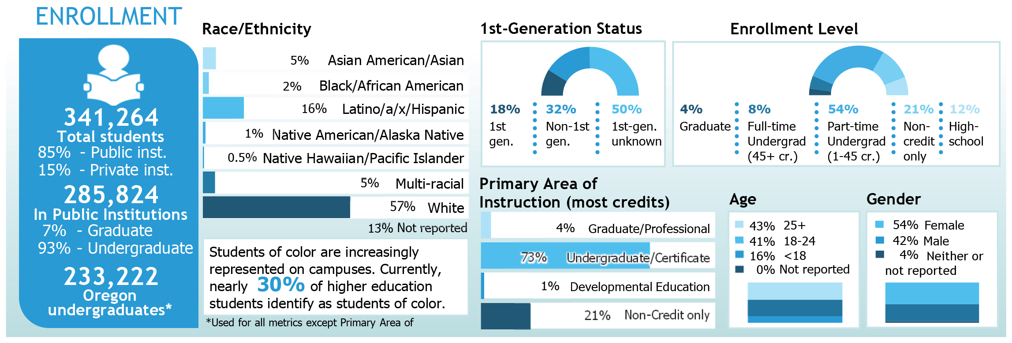
Fig. xx Caption (Alt text and long description to be added)
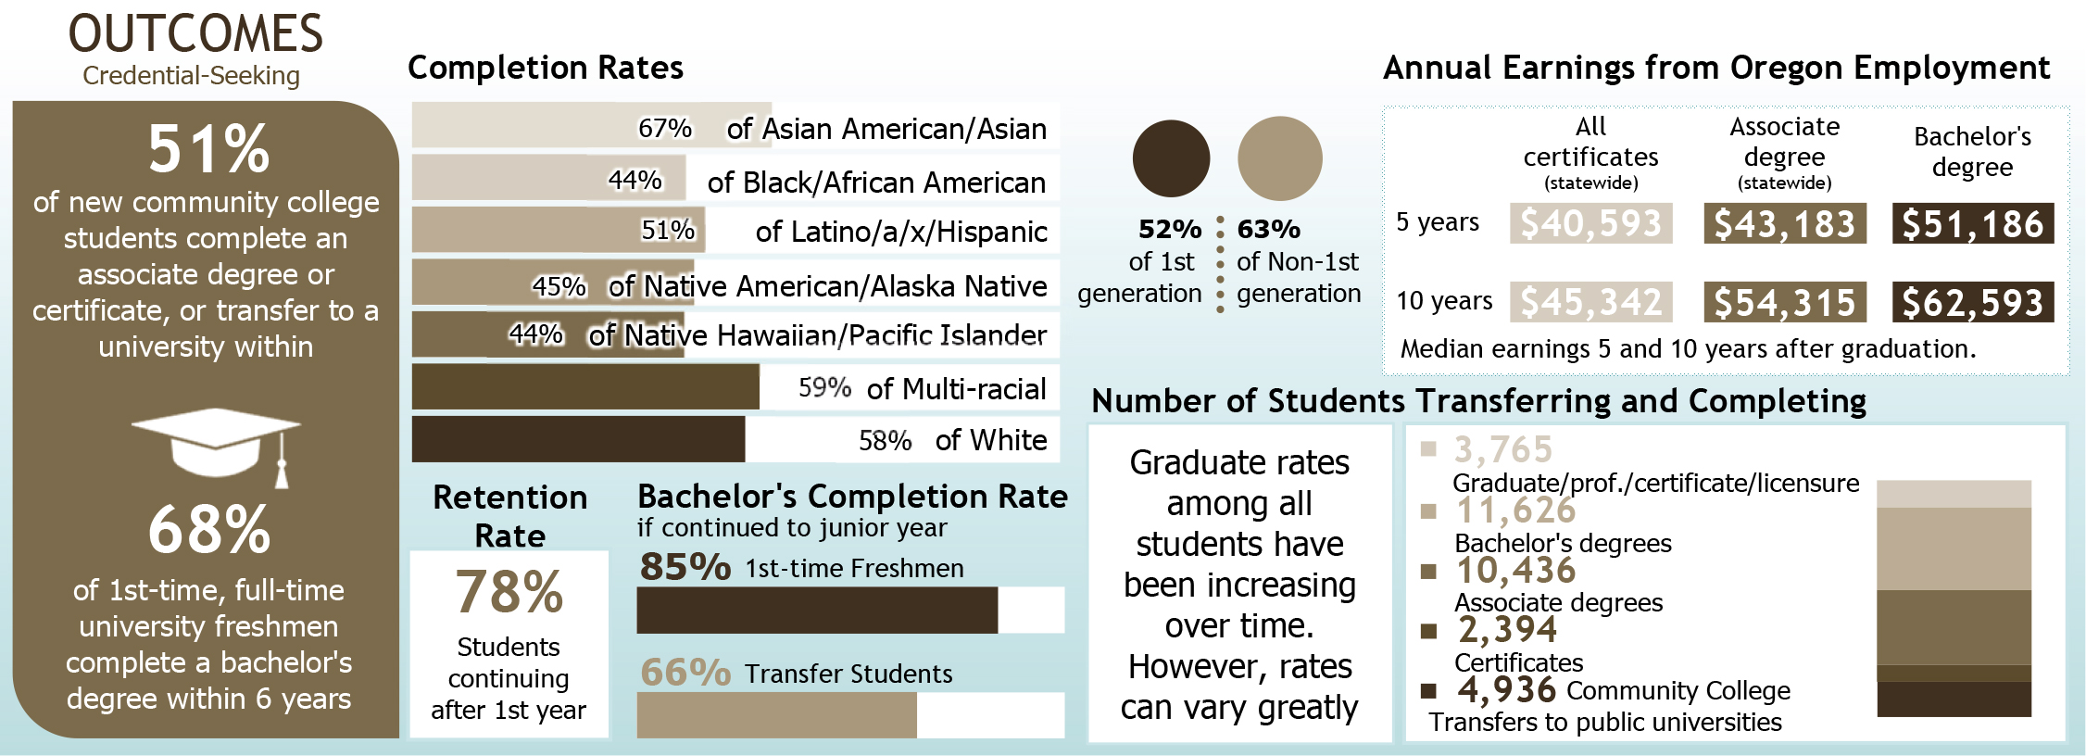
Fig. xx Caption (Alt text and long description to be added)
When you look at the information provided in this snapshot, what stands out to you? Think about your first-generation and/or low income students who deal with financial and institutional barriers to completing their education. Take a moment to reflect on the experience of your students of color, LGBTQ+ students, or students with disabilities who routinely deal with microaggressions in the classroom. How do you think these barriers and microaggressions contribute to – and exacerbate – the inequalities that you see in the snapshot?
As a part of the Targeted Pathways Project, one of our commitments is “sharing course materials that directly address and interrogate systems of oppression, equipping students and educators with knowledge to do the same.” As you learn to use an equity lens, and write for Diversity, Equity, and Inclusion (DEI), it’s important to understand that your work as authors is about more than just the textbook. When you write for DEI, your textbook has the potential to be both an educational resource and a source of representation for marginalized experience. In this introduction, we’ve talked a lot about the ‘big picture.’ There’s a lot of different histories and lived experiences to consider, and you may be wondering exactly how to keep the big picture in mind as you write for DEI. It’s helpful to have something concrete to reflect on, so take a moment to review our project’s DEI statement. Think of this statement as a way to guide your ‘big picture’ thinking as you write and revise your textbooks:

Open Oregon Education Targeted Pathways Project: DEI Statement
“The Open Oregon Educational Resources Targeted Pathways Project seeks to dismantle structures of power and oppression entrenched in barriers to course material access. We provide tools and resources to make diversity, equity, and inclusion (DEI) primary considerations when faculty choose, adapt, and create course materials. In promoting DEI, our project is committed to:
- Ensuring diversity of representation within our team and the materials we distribute
- Publishing materials that use accessible, clear language for our target audience
- Sharing course materials that directly address and interrogate systems of oppression, equipping students and educators with the knowledge to do the same
Designing and piloting openly licensed, intersectional, and antiracist course materials is one starting point among many when addressing inequities in higher education. Our project invites students and educators to engage with us in this work, and we value spaces where learning communities can grow and engage together.
We welcome being held accountable to this statement and will respond to feedback submitted via our contact page.”
The main purpose of OOER’s Targeted Pathway Project is to create course materials with an equity lens. This can be challenging work, and it’s important to remember the ‘big picture’: you’re creating materials that call out these issues, and require students and educators to have informed, honest dialogues. As authors, think about how the above equity statement applies to the day-to-day work of textbook writing and revising. It may be helpful can use the following three points to guide your thought-process:
- Think about how the project’s materials are reflecting on/discussing social justice issues related to your field of work/expertise.
- Don’t gloss over DEI issues in your field: take the time to frame textbook content that critically engages these topics.
- Reflect on the current culture of advocacy, reform, and the history of disparities/injustices in your field. Highlight the positive changes being made in your field, as well as the progress that still needs to be made.
CONCLUSION: Module Recap & Textbook Tips
As an author, you’re taking on the responsibility of creating content that will shape classroom conversation and highlight the experiences of communities that are often dismissed in higher education.
An interactive H5P element has been excluded from this version of the text. You can view it online here:
https://openoregon.pressbooks.pub/dothework/?p=191#h5p-10
Writing a textbook that centers around using an equity lens and incorporates considerations for diversity, equity, and inclusion is labor-intensive work. It is a process and requires:
- A commitment to ongoing review and revision, including reading and revising multiple times (just as we prompt students to do in their work)
- Examination of the content and the way it is presented to ensure that it is inclusive and respectful of all individuals, regardless of their race, gender, age, ethnicity, sexual orientation, and abilities
- Reflection and taking time to pause and consider your own internal biases and perspectives
- Working with subject matter experts and community representatives from diverse backgrounds to ensure that the content is accurate, relevant, inclusive, and free of bias and stereotypes; this includes images and visual representation.
- Bookmark the Open Images webpage on the Open Oregon website for recommended places to search for openly licensed images and visit it often!

Licenses and Attributions

Open Content, original
“Writing Textbooks with an Equity Lens” by Heather Blicher and Valencia Scott for Open Oregon Educational Resources [Website] is licensed CC BY 4.0.

References
Oregon Higher Education Coordinating Commission. (2022). Statewide higher education snapshots. Salem: Oregon. https://www.oregon.gov/highered/research/Documents/Snapshots/Statewide-Snapshot.pdf
OHSU Center for Diversity and Inclusion. (2021). Inclusive language guide. https://www.ohsu.edu/sites/default/files/2021-03/OHSU%20Inclusive%20Language%20Guide_031521.pdf
The University of British Columbia, CTLT Indigenous Initiatives. (n.d.). Positionality & intersectionality. https://indigenousinitiatives.ctlt.ubc.ca/classroom-climate/positionality-and-intersectionality/#:~:text=Positionality%20refers%20to%20the%20how,identities%20and%20access%20in%20society.
University of Michigan LSA. (n.d.). The spectrum activity, questions of identity. Inclusive Teaching. https://sites.lsa.umich.edu/inclusive-teaching/the-spectrum-activity-questions-of-identity/
Screenshot from World Geography © McGraw-Hill is included under fair use.

Additional Reading (and Listening):
Kendi, I.X. (2019). How to be an anti-racist. One World.
NEASC Virtual Global Forum. (2021). Redesigning curriculum through a diversity, equity, and inclusion lens. https://youtu.be/u3Cfbua9KJg
National Museum of African American History. (n.d.). Talking about race: Being antiracist. https://nmaahc.si.edu/learn/talking-about-race/topics/being-antiracist

1.5 Apply and Submit
Heather Blicher and Valencia Scott

Instructions for Apply and Submit
- Please read the entire module before completing the Apply and Submit activity.
- Go to your “Revising and Feedback Documents (Year 2 & 3)” folder in your Google Drive author folder.
- Open the document titled “Doing the Work: Apply and Submit Activities (Modules 1-5)”
  - Read the Activity Prompt for Module 1.
  - Complete the activity in the Revising Author Submission column for Module 1.
  - You can complete the activity in an optional Zoom workshop meeting (link below) or on your own.

- Submit the activity for feedback using the Doing the Work Apply and Submit Google Form by Monday, March 20, 9am.

Optional Zoom workshop meeting information:
- Attend a 50-minute Zoom meeting to complete the activity, ask questions, share, and get feedback on your work before submitting.
  - Friday, March 17, 3-3:50 pm, https://linnbenton.zoom.us/j/94531683073

II

Module 2: Inclusive Textbook Revision
Click on the + in the Contents menu to see all the parts of this chapter, or go through them in order by clicking Next → below

2.1 Overview
Stephanie Lenox and Abbey Gaterud

Learning Objectives
- Distinguish between revising and editing.
- Develop a revising mindset informed by the principles of inclusive revision.
- Recognize personal and systemic biases in textbook writing.
- Apply the principles of inclusive revision to textbook writing.
Over the past year, the authoring teams for the Targeted Pathways Project have accomplished a major feat: developing and creating textbooks and courses with an equity lens. And now, these educational resources have been used in classrooms, reviewed by peers, and put to the test. This next revision phase involves an important step in achieving the project’s diversity, equity, and inclusion goals. It is a time to reflect on what has been accomplished and, as the title of this book suggests, keep doing the work by asking questions and seeking ways to improve through inclusive revision.

Licenses and Attributions

Open Content, original
“Overview” by Stephanie Lenox and Abbey Gaterud for Open Oregon Educational Resources [Website] is licensed CC BY 4.0.

2.2 What Revision Is and Is Not
Stephanie Lenox and Abbey Gaterud



Revision means literally “to see again.” It’s not easy to see clearly something that you’re really close to. In order to make meaningful changes and improvements to what is on the page, authors need to step back to look at the text through the eyes of the student reader. When working under a deadline, you might not always have the advantage of a lot of time away from a manuscript to see it with fresh eyes. But you can cultivate a revising mindset by using the strategies and approaches described in this module.
Two distinct purposes govern the writing and revising mindsets. When you write, your primary goal is to get the words down on the page. When you revise, your goal is to fix the words up for the reader. The reader’s experience should guide all changes you make at this stage.“… we see our manuscript through a split lens: through one half, we view what is really there; through the other, what could be.”
— Susan Bell, The Artful Edit
As editor Susan Bell explains in her book The Artful Edit, “When we [revise], we see our manuscript through a split lens: through one half, we view what is really there; through the other, what could be.”
Inclusive revision isn’t just about eliminating exclusionary language; it’s about ensuring that every part of your text serves the needs of students first. An antiracist textbook supports all learners by calling attention to the contributions of historically underrepresented scholars and calling out how your discipline has contributed to systems of oppression that lead to social injustices and disparities. This approach to revision takes considerable time, deliberate effort, and thoughtful reflection.
To begin, let’s take a look at what revision is and is not.

Revision Is . . .
Revision is all about learning to see the possibilities for change. This step involves letting go of the authoring role and embracing the fact that the book is not yet complete. The box below describes some of the essential tasks for inclusive revision.

Strategies for Inclusive Revision
- clarify and focus the content to ensure it serves the intended purpose
- consider the book’s structure, organization, and flow
- diversify the sources or scholars that support the instructional content
- maintain a reading level (grades 8-12) suited for the book’s audience and purpose
- address issues of tone, style, and voice to enhance the book’s readability
- address feedback from peer reviewers, instructors, and students
Your role as revising authors involves looking at how to make macro-level and micro-level changes to ensure that your book will meet the DEI goals of this project. In the table below, you’ll notice that the same topics appear in macro-level and micro-level revision categories with a slightly different focus. Each of the bullets represents examples of how you can focus your revision on macro-level or micro-level issues.
If this feels like a lot to keep in mind while you’re revising, don’t worry! It’s not effective or reasonable to attempt to do macro- and micro-level revisions at the same time. Revision often requires multiple read-throughs and attempts, so plan to take several passes at revision during this phase.

Revision Is Not . . .
Revision can sometimes feel like you’re taking a step back. This step back, however, is necessary for you to get clarity on the work. In the long run, it will help your team move forward more effectively and inclusively.
Because revision encompasses many activities, it can help to define it by what it is not. Revision does not fix:
- grammar
- spelling
- punctuation
- capitalization
- formatting
- layout
Revision is not editing. Revision is not proofreading. These are distinct phases of the textbook production process that will take place at a later time.
If you come across a typo or a factual error, by all means, fix it! Just remember that fixing mistakes isn’t revising. Revision is hard, and staying focused on the big picture takes discipline. The next page discusses the “revising mindset” and how to think like an editor to help you move toward a more complete and inclusive textbook.

Licenses and Attributions

Open Content, original
“What Revision Is and Is Not” by Stephanie Lenox and Abbey Gaterud for Open Oregon Educational Resources [Website] is licensed CC BY 4.0.

Bell, Susan.
. New York: W. W. Norton, 2007.

3

2.3 The Revising Mindset
Stephanie Lenox and Abbey Gaterud
Your role as a revising author is to assess the current state of the textbook, create a plan for revising the text to meet the goals of the Targeted Pathways Project, and address feedback from peers and pilot instructors. The Targeted Pathways team will help you develop and implement a revision plan, but you can facilitate this process by embracing the revising mindset.

Strategies for Maintaining a Revising Mindset
Here are example strategies for getting into the revising mindset:
- Cultivate creative distance: The most valuable tool for a revising author is to take a step back from the text, either literally or figuratively. Sometimes, when you’re stuck, a walk around the block is all it takes to get some distance between you and what you’ve written. The more you can let go of all the work you’ve done so far, the more you’ll be able to see what is actually on the page, what’s missing, and what needs to change.
- Prepare for change: It’s natural to resist feedback that asks you to change something that you worked hard to create. It’s much easier to justify why the text is fine the way it is. Ready yourself to be open to the feedback you will receive so you can use your creative energy to move forward rather than rationalize the status quo.
- Look at the big picture: Revision requires you to be familiar with the entire text, not just the part you’re responsible for writing. Get acquainted with the book from start to finish, and take notes as you go. This is what you’ve been doing as part of your manuscript self-assessment.
- Read like a student: Imagine what it’s like to read your text after working the night shift while caring for a sick child or parent. Try reading the textbook on your phone while riding the bus. What can you do for this student to make the concepts more relevant, accessible, and manageable? Start your revisions by cutting everything that doesn’t absolutely need to be a part of the text.
- Switch formats: If you are one of the original authors of the text, try reading your book in a format other than the one you used to create it. For instance, if you composed chapters on your laptop, print out the chapters and read them in hard copy. Or use a screen reader to hear what your chapter sounds like to a student using this tool. Sometimes changing the font or format is all it takes to make the text feel new again.

Start with CARE
At every step as you’re reading the text, take notes and challenge yourself using the CARE model of revising developed by your Instructional Editor Stephanie Lenox.

CARE Model of Revision
- C – What can I cut? What can I clarify?
- A – How can I best address the feedback I’ve received?
- R – How can I reorder for clarity or to avoid redundancy?
- E – How can I use examples to make my text more relevant?

Licenses and Attributions

Open Content, original
“The Revising Mindset” by Stephanie Lenox and Abbey Gaterud for Open Oregon Educational Resources [Website] is licensed CC BY 4.0.

4

2.4 The Work: Revising for Inclusion
Stephanie Lenox and Abbey Gaterud
As a revising author of a textbook, you have your work cut out for you. The genre of textbook writing has a long history of being racist and exclusionary. As Charles W. Mills writes in The Racial Contract, “standard textbooks and courses have for the most part been written and designed by Whites, who take their racial privilege so much for granted that they do not even see it as political, as a form of domination.” Textbooks have often legitimatized certain kinds of knowledge while marginalizing others. You have an opportunity to challenge this history and offer a different pathway to understanding.

Explicit and Implicit Bias in Textbooks
Explicit bias in a textbook is easy to spot. It may involve the use of stereotypical examples or incorrect/dated terms to describe someone’s race, ethnicity, gender, economic status, and so forth. Explicit bias in textbooks can be pointed out on the page.
Implicit bias can be harder to spot in a textbook because it is based on what’s not on the page. It might be implied through tone. It might be a lack of discussion of scholars of color or an over-emphasis on “the greats” (who just happen to all be White and male). It might be found at the sentence level, with references to “men and women,” rendering invisible readers who don’t identify as either.
For more descriptions of biases found in textbooks and curricular material, explore this additional resource from the Myra Sadker Foundation.

Red Flags in Textbook Writing
Bias can be subtle and difficult to recognize, especially in your own writing. As an instructional editor, I have identified what I call “textbook mode” as one of the brightest red flags for biased writing. Textbook mode is a default style of writing that is easy for many academic writers to reproduce because you’ve spent so much of your career reading dense, dry, and demanding scholarly work.

Warning Signs of Default Textbook Mode
- Trying to “get it right” rather than acknowledging complexity.
- Worrying about “dumbing down” the content rather than making the content accessible.
- Justifying a Eurocentric focus because students need to know “the basics” first.
- Expecting students to “look it up” if they don’t know something rather than explaining the context of background.
- Assuming students bring your level of enthusiasm for the topic rather than engaging them in mutual excitement.
Inclusive revision requires the creative application of empathy to the written text. This is your opportunity to put yourself in the reader’s place and imagine the text from their position. To approach your revision with an equity lens, look for opportunities to reinforce the principles of accountability, specificity, precision, and humanity. We’ll take a closer look at these principles on the next page.

Licenses and Attributions

Open Content, original
“The Work: Revising for Inclusion” by Stephanie Lenox and Abbey Gaterud for Open Oregon Educational Resources [Website] is licensed CC BY 4.0.

Mills, Charles W.
. Ithaca, NY: Cornell UP, 1999.

5

2.5 Principles for Inclusive Revision
Stephanie Lenox
To approach your revision with an equity lens, look for opportunities to reinforce the following principles:
- Accountability
- Specificity
- Precision
- Humanity
We’ll revisit and apply these principles in the next section.

Accountability
Macro level: acknowledge and take responsibility for the ways your discipline has contributed to systems of power and oppression that have resulted in the marginalization of people.
Example
“The American Psychological Association failed in its role leading the discipline of psychology, was complicit in contributing to systemic inequities, and hurt many through racism, racial discrimination, and denigration of people of color, thereby falling short on its mission to benefit society and improve lives. APA is profoundly sorry, accepts responsibility for, and owns the actions and inactions of APA itself, the discipline of psychology, and individual psychologists who stood as leaders for the organization and field.” Read the full statement here.
Micro level: ensure your sentences are active and direct so it is clear who is responsible for the action.
Example
In this example, the passive voice does not acknowledge the actor in the sentence: “Slaves were considered property.” Instead, try revising so the actor is visible in the sentence: “Enslavers treated captive Africans as property.” For more about accountability at the micro-level, see this resource about writing about slavery.

Specificity
Macro level: give specific names, background, and context to ideas rather than assuming familiarity.
Example
Instead of a statement like “Many people in society experience inequality,” spend more time teasing out the specifics: “Social inequality is a pervasive issue in contemporary U.S. society. According to recent studies, income inequality has been increasing steadily over the past several decades, with the top 1% of earners holding an increasingly large share of the country’s wealth. Additionally, racial and gender disparities in access to education, healthcare, and job opportunities continue to persist, leading to unequal outcomes for individuals from marginalized communities. These patterns of inequality can have far-reaching consequences for both individuals and society as a whole.” In this revised statement, the author has specified the type of inequality they are referring to (social inequality), provided evidence to support the claim, and identified the potential consequences of this inequality.
Micro level: use specific, concrete examples to bring abstract ideas to life.
Example
Socialization is an abstract concept. But when you describe what socialization looks like or feels like, it becomes more concrete (perceivable through the five senses). Use “for example” or “for instance” to help students connect the new idea to something they’re already familiar with.

Precision
Macro level: revising for precision means focusing on what matters and getting rid of anything extraneous. A common barrier to student understanding is not knowing what’s important or what to focus on.
Example
The cardinal rule of revision for precision can be summed up in this quote by William Zinsser from On Writing Well: “Writing improves in direct ratio to the number of things we can keep out of it that shouldn’t be there.”
Micro level: define essential terminology so readers have a precise, shared understanding of important concepts.
Example
This example shows how to define specialized language for a general audience: “The property that a person leaves behind when they die is called the decedent’s estate. The decedent is the person who died. Their estate is the property they owned when they died.”

Humanity
Macro level: feature scholars from marginalized communities and connect concepts to readers’ lived experiences.
Example
Featuring scholars from marginalized communities means placing them on equal footing with the “founding fathers” of your discipline.
Micro level: use student-centered, person-first, or identity-first language.
Example
Address the reader as “you.” Provide examples that include people. Avoid phrases like “the poor” or “the mentally ill” that reduces people to a label. For more, see this resource on person-centered language.

Licenses and Attributions

Open Content, original
“Principles for Inclusive Revision” by Stephanie Lenox for Open Oregon Educational Resources [Website] is licensed CC BY 4.0.

2.6 Applying Inclusive Language
Stephanie Lenox
Inclusive language involves an intentional effort on the part of the writer to eliminate bias, assumptions, stereotypes, and barriers to understanding.
The first step in writing effectively for diverse student audiences is to recognize that language is a product of culture and reflects the culture’s systems of power and oppression. But language can also shape thought and promote change. Conscious and deliberate choices in the words we use can counter the ingrained biases that affect the way we think about and see the world.
The following excerpts come from openly licensed texts. Please note this content may include ideas and descriptions that are offensive or upsetting. The revisions attempt to address the issues from the original texts. Notice how the color-coded highlighting follows the principles of inclusive language. To explore these excerpts without color coding, please see this alternative format for the examples below [PDF].

Example 1
Original: On August 9, 2014, Michael Brown, an African American male, was shot and killedby the police in Ferguson, Missouri.
Revision: “On August 9, 2014, Michael Brown, an 18-year-old Black teenager from Ferguson, Missouri, was killed after White police officer Darren Wilson shot him six times.”
- Precision: Changing “African American” to “Black” reflects the current preferred term when discussing matters of race. The addition of the police officer’s race provides an essential detail that’s part of this encounter. “Male” and “female” are best reserved for non-human animals; the simple addition of the masculine pronoun is sufficient to convey Michael Brown’s gender.
- Specificity: The number of shots fired helps the reader understand the degree of violence in this police encounter.
- Humanity: Adding “18-year-old teenager” helps the reader understand who Brown was.
- Accountability: Naming the police officer shows who is responsible for this action. This revision addresses a rhetorical device commonly known as the past exonerative tense, which is often used in media accounts, political writing, and police reports.

Example 2
Original: One long-standing explanation is that blacks and other people of color are biologically inferior: They are naturally less intelligent and have other innate flaws that keep them from getting a good education and otherwise doing what needs to be done to achieve the American Dream. As discussed earlier, this racist view is no longer common today. However, whites historically used this belief to justify slavery, lynching, the harsh treatment of Native Americans in the 1800s, and lesser forms of discrimination.
Revision: One long-standing explanation that has no scientific basisfor why racial and ethnic inequalities exist is that Black people and other people of color are biologically inferior. This racist belief claims that some people are naturally less intelligent and capable than others. The concept of the biological inferiority of other races is a central belief of White supremacy and has been used historically to justify slavery, lynching, and systematic destruction of Indigenous peoples and their cultures.
- Accountability: Call out theories and beliefs that are racist or not supported scientifically.
- Specificity: Make sure to fill in all the details, even if you think the subject or context is clear.
- Humanity: Avoid using adjectives to describe people: “the poor,” “the homeless,” “the Blacks,” “the unvaccinated,” etc. This linguistic shortcut tends to reduce a group of people to a single characteristic.
- Precision: This revision has a more precise focus on White supremacy in order to avoid giving unintended legitimacy to the concept of biological inferiority.

Example 3
Original: In a multicultural society, one crucial question is: Are standardized tests biased against certain social classes or racial and ethnic groups? This question is much more complicated than it seems because bias, as we explored in Chapter 1, has a variety of meanings. An everyday meaning of bias often involves the fairness of using standardized test results to predict potential performance of disadvantaged students who have previously had few educational resources. For example, should Dwayne, a high school student who worked hard but had limited educational opportunities because of the poor schools in his neighborhood and few educational resources in his home, be denied graduation from high school because of his score on one test. It was not his fault that he did not have the educational resources and if given a chance with a change his environment (e.g. by going to college) his performance may blossom. In this view, test scores reflect societal inequalities and can punish students who are less privileged and are often erroneously interpreted as a reflection of a fixed inherited capacity.
Revision: Dwayne, a Black high school student, works hard to get good grades at his under-resourced school. At home, his mom works evenings and isn’t around to help with homework. During the COVID-19 pandemic, he attended class online but had to share the family’s computer and unreliable wifi with his eighth-grade sister. Now he’s about to take a skills test to determine whether he graduates. Should a single, high-stakes test decide Dwayne’s future? What do standardized tests really measure?
Recent research has shown that test scores–and even the questions they ask–reflect socioeconomic inequalities (citation). These tests and the interpretation of their results disproportionately and negatively impact students who come from low-income communities and racial or ethnic minority groups (citation). In a multicultural society, we as criminology students must ask this: How do biased standardized tests, both in the schools and in our field, impact certain social classes or racial and ethnic groups? This question is much more complicated than it seems because bias, as we explored in Chapter 1, shows up in a variety of ways.
- Humanity: You can use a people-first approach at the paragraph level by leading with a personal example that humanizes your subject.
- Precision: The focus of this section is on racial bias in standardized testing, yet the original doesn’t mention Dwayne’s race at all. This is a relevant and essential detail.
- Accountability: Citing your sources and showing where ideas come from is one way of demonstrating accountability.
- Specificity: Whenever you use “we,” be specific about who is included in that group. This level of specificity helps students see themselves as part of the in-group that can instigate change. Avoid the “editorial we” when referring to general groups of people.
- Other notes: Notice how the revision breaks up this paragraph into smaller chunks for readability and begins with the specific and moves to the general, which guides students from known and familiar experiences to new information.

Example 4
Original: The fear that there would be a slave revolt was the main reason the death penalty was imposed with the belief that it would be a deterrence for Blacks who weren’t murdering whites but possibly destroying commodities or goods and also slaves who may have thought of running away or attack a white in any manner.
Revision: White enslavers feared that the people they held as slaves would revolt in order to gain freedom. Law enforcement used the threat of the death penalty to deter Black people from fighting back or destroying goods in protest.
- Accountability: Use active voice to make it clear who is doing what in each sentence. This is an important strategy for holding people accountable for their actions.
- Humanity: Especially when writing about slavery, take a people-first approach. See this resource for guidance.
- Specificity: Why did enslaved people revolt? Specificity makes sure students see the entire picture.
- Precision: The original sentence is muddy and tries to do too much. Sometimes using shorter sentences and saying less can be the key to precision.

Licenses and Attributions

Open Content, original
“Applying Inclusive Language” by Stephanie Lenox for Open Oregon Educational Resources [Website] is licensed CC BY 4.0.

2.7 Apply and Submit
Stephanie Lenox and Abbey Gaterud

Instructions for Apply and Submit
- Please read the entire module before completing the Apply and Submit activity.
- Go to your “Revising and Feedback Documents (Year 2 & 3)” folder in your Google Drive author folder.
- Open the document titled “Doing the Work: Apply and Submit Activities (Modules 1-5)”
  - Read the Activity Prompt for Module 2.
  - Complete the activity in the Revising Author Submission column for Module 2.
  - You can complete the activity in an optional Zoom workshop meeting (link below) or on your own.

- Submit the activity for feedback using the Doing the Work Apply and Submit Google Form by Monday, April 3, 9am.

Optional Zoom workshop meeting information:
- Attend a 50-minute Zoom meeting to complete the activity, ask questions, share, and get feedback on your work before submitting.
  - Friday, March 24, 3-3:50 pm, https://linnbenton.zoom.us/j/93327445901

III

Module 3: Working Toward Accessibility: Expanding Your Universe of Learners
Click on the + in the Contents menu to see all the parts of this chapter, or go through them in order by clicking Next → below

3.1 Overview
Veronica Vold

Learning Objectives
- Contextualize disability in the project’s DEI framework.
- Explain how accessibility fits into the Multiple Means of Representation, a foundational principle of Universal Design for Learning.
- Evaluate how image information (including figure captions, alt text, and image descriptions) can best serve students, including students who use screen reader software.
- Create figure captions, alt text, and image descriptions following best practices with DEI in mind.
- Revise links so that they are descriptive and include their destination in the link text itself.
- Situate accurate media captions and transcripts as a strategy for Multiple Means of Representation, a foundational principle of Universal Design for Learning.
- Explain how the project support team can assist with media captions and transcripts.
When you revise course materials to improve accessibility, you expand the universe of learners who are welcome and included in higher education. People with disabilities are often overlooked in discussions of DEI. When course materials are accessible to students with disabilities, you affirm that diverse ways of learning, experiencing, and expressing knowledge are not only accepted or tolerated but are valid and valuable.
Designing for accessibility aligns with antiracist and queer-inclusive design. Students with disabilities carry diverse experiences of race and sexuality. For example, people with disabilities who are queer women of color bring strategies and claims on disability identity, community, and inclusion that are distinct from their white and straight disabled peers. Digital accessibility increases the dynamic exchange of knowledge, expertise, and problem solving in learning spaces. When course materials are accessible, they protect not only access to information and the opportunity to create knowledge itself.
Accessibility also aligns with ensuring multiple means of representation, a foundational principle of Universal Design for Learning. Providing multiple means of representation means planning for learner variability, or anticipating that your students will need more than one way to receive information. For example, to ensure access to information for blind or low vision students, images include alternative text as well as image descriptions when images are complex. To ensure all users can navigate between tabs with ease, links describe their destination and format rather than listing a url alone. Audio/visual media includes media captions and transcripts so that users who are hard of hearing or Deaf have equitable access to media information.
In the video below, students who use accessible technology describe what it means to them. As you watch or read the transcript, take note of what students care about the most. What quotes stand out to you? What phrases do you want to remember as you revise this textbook for accessibility?
One or more interactive elements has been excluded from this version of the text. You can view them online here: https://openoregon.pressbooks.pub/dothework/?p=59#oembed-1
Fig. 3.1 In this 2021 YouTube Video from the National Center on Accessible Course Materials, students describe what accessible technology means to them.
Improving the accessibility of course materials is a collaborative process. No one person can do it alone. Take note of your support team (fellow revising authors! campus partners! support staff!) who can help you to meet accessibility standards in your content revision. Our support team will ensure that your revised textbook meets several accessiblity standards in our final review of the textbook. These standards include:
- Appropriate page structure (headings, lists, tables)
- Appropriate page organization in your Pressbook
- Appropriate use of color, both in terms of color contrast and avoiding use of color alone to convey meaning
However, there are accessibility standards that depend on your role as a subject matter expert. These tasks must be completed by a revising author with expert knowledge of the purpose of an image, link, or media feature. These tasks include:
- writing figure captions, alt text, and image descriptions
- writing descriptive links
- checking for accuracy in media captions and transcripts
In the next section, we’ll go over basic aspects of these last three tasks and give you a chance to practice working with alt text, image descriptions, and figure captions, as well as managing links and media captions!

Licenses and Attributions

All content by Veronica Vold for Open Oregon Educational Resources [Website] is licensed under CC BY 4.0.

3.2 What are Figure Captions, Alt Text, and Image Descriptions?
Veronica Vold
As you saw in Game Changing Technology [YouTube Video], many people rely on screen reader software to access content, including users who are blind or have low vision. Adding alt text and long image descriptions when needed ensures everyone can access visual information. This strategy aligns with Multiple Means of Representation, a foundational principle of Universal Design for Learning. In our textbooks, every image also has a figure caption. The content in the figure caption will help you determine what should go in the alt text or long description. Let’s discuss how these three parts – figure captions, alt text, and image descriptions – work together.

Key Definitions
Figure Captions are one to two sentences of textual description that contextualize the image content within the surrounding text. Every image in your textbook includes a figure number as well as a figure caption. Figure captions often pose a question, draw a contrast, or explain an illustration. The caption is readable to all textbook users with or without screen reader software.
Alt text, or alternative text, is the short text substitute for visual information conveyed by an image, chart, or graph. Alt text can also be called an “alt tag.” Typically, alt text is only read by users who use screen reader software. It isn’t visible on the page. Alt text is not necessarily a literal description of the image. Instead, alt text aims to capture any visual information that relates to the purpose of the image.
Image descriptions include rich detail and are longer than alt text. Image descriptions convey numbers, trends, and patterns that alt text and figure captions usually won’t describe. Image descriptions accompany alt text when more than 10 words are necessary to communicate the relevant visual information. This is often the case for infographics, charts, and graphs. In these cases, the alt text can also include the phrase “Image Description Available.” Image descriptions are intended for users who need more detail about the visual information of an image. Often these users will include people who may not use screen reader software but who benefit from more orientation to visual information. In our project, image descriptions will be linked next to an image, which will bring users to the bottom of the Pressbook page. All users will be able to access them. Image descriptions will be included in print versions as well.

Key Examples
Sometimes the figure caption will convey all relevant detail about the visual information in the image already. If this is the case, adding alt text is redundant. Adding alt text is only necessary when the visual information conveyed by an image is not otherwise available to users who use screen reader software. Here is an example of when alt text is not necessary because the figure caption is quite detailed:



Most of the time, however, the figure caption won’t summarize the visual information of an image in detail and alt text will be necessary. Here’s an example:



In the above figure caption, the visual information of the image is not described in the caption itself; the image supplements the text. In order to convey the visual information, the alt text reads: “An unzipped glucometer kit and accessories.”
Please note: Sometimes alt text will include information that is relevant to all users but only appears in alt text. In these cases, the information should be moved to the figure caption instead. For example, let’s say that the alt text for the above image listed each accessory, but the list wasn’t available in the surrounding text or figure caption. This would mean that the alt text had relevant information but didn’t share it with all users. The list of accessories would need to be included in the surrounding text or figure caption.

What do I do if there is no alt text or image description for an image?
To determine if you need to add alt text or an image description, start by considering purpose of an image. Some images are informative in that they convey important content. This means they are considered meaningful to the argument, guiding question, or message of a work. Other images only break up the visual flow of a page or just add visual interest. These images are considered decorative. If an image is decorative, it requires no alt text. Most images in this project will be informative and will require alt text and/or image descriptions when the figure caption doesn’t already convey key visual information.

Self-comprehension Check
Select the four hot spot icons below to learn more about the parts of a figure, including figure number, figure caption, image description, and alt text.
An interactive H5P element has been excluded from this version of the text. You can view it online here:
https://openoregon.pressbooks.pub/dothework/?p=62#h5p-13

Licenses and Attributions

Open Content, used previously
Definitions for alt text and image descriptions is adapted in part from “Images” in Accessibility Toolkit – 2nd Edition by BCcampus licensed under a Creative Commons Attribution 4.0 International License
Image: Portland Oregon neon signage during nighttime by Zach Speak on unsplash
Image: Gestational diabetes kit by Stevenfruitsmaak on Wikimedia is is licensed under the Creative Commons Attribution 2.0 Generic license.
Image: Wheel of Power and Privilege in Exploring Figure Captions, Alt text, and Image Descriptions Hotspot is based on the work of Patricia Hill Collins, Kimberlé Crenshaw and Allan Johnson, and the visual images of Sylvia Duckworth and the Canadian Institutes of Health Research. This version designed by Kimberly Puttman, Michaela Willi Hooper, and Lauren Antrosiglio, Open Oregon Educational Resources, CC BY 4.0.
Open Content, original
All other content by Veronica Vold for Open Oregon Educational Resources [Website] is licensed under CC BY 4.0.

6

3.3 Writing Figure Captions, Alt Text, and Image Descriptions
Veronica Vold

Writing Figure Captions
Remember: all users of the textbook will read figure captions. This means that you are writing for your broadest audience. When revising figure captions, keep the following in mind:
- Be descriptive. The goal of the figure caption is to help users understand the purpose of the image without needing to read the rest of the page.
- Synthesize major themes. Direct reader attention to the information the image conveys in a new, but related way to the paragraphs of text around the image.
- Keep it short. If you find yourself writing more than one or two sentences in a figure caption, shift any additional phrases to the surrounding paragraphs of text or the image description. This will allow you to elaborate on the image and its relationship to your learning objectives without making it too heavy for readers.

Figure Caption Examples
The following two examples of figure captions accompany an image from a section on collaboration in the first chapter from Introduction to Human Services. The first example is a satisfactory figure caption. The second example (the actual caption in the chapter!) is even stronger.
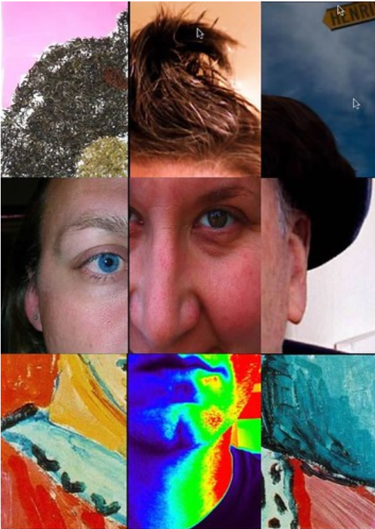
Example 1: Figure 3.4 Lots of learners find their fit in the human services field.
Example 2: Figure 3.4 Collaboration amongst multidisciplinary agencies and individuals can feel disjointed, but it is important to work together toward the best quality of life for clients.
Both of these figure captions are good. They both include figure numbers and provide a short, concise statement as the caption. They also both orient introductory students to the career of human services. However, what sets them apart is the degree of alignment with chapter content and the interpretative claim they make about the image itself. The first figure caption encourages students that they can “find their fit” in human services, perhaps drawing on the puzzle-like appearance of the composite portrait. However, the second figure caption draws on a key term discussed in the chapter section: collaboration. It also references the “disjointed” feeling of different service providers working together on behalf of a client, much like the composite portrait itself feels jointed and strains to form a human face. This caption interprets the image in support of a core claim in the chapter section. It also directly references the tension and problem of collaboration when services are siloed. In this way, it directs reader attention in a new, but related way to the text itself.

Writing Alt Text
When writing alt text, you are writing for members of your audience who can’t access relevant visual information an the image. People without screen reader software won’t access alt text information. When figure captions don’t describe the visual information, follow these guidelines to write alt text:
- Keep it short (usually 10 words or less). Screen reader users expect short alt text phrases. If you have a lot to say, include more info in the accompanying image description or in the figure caption.
- Avoid the phrase “picture of” or “image of.” The screen reader software will say “graphic” as part of reading the alt text. If the medium of the image is relevant to its meaning, for example, a painting or a handwritten letter, it’s fine to include this info.
- When describing people, don’t assume race or gender. Unless someone’s race or gender is self-described, do not assign people social identities. You can use terms like “dark skin tone” or “light skin tone” and note hairstyle, clothing, and physical build. Remember: the Targeted Pathways project aims for diverse representation in images. Alt text should reference this diverse representation as well.
- Consider the context for the image. Different contexts will require different alt text for the same image. For example, alt text for an image of a child riding a bus for a sociology chapter that analyzes inequitable access to public transit by race might describe the skin tone of the people on the bus as well as features of the city street. The alt text for that same image in a math textbook might describe the skin tone of people on the bus as well as the bus schedule as it relates to a relevant problem set.
- If the image is decorative rather than meaningful, mark it as decorative. Most images in our textbooks are informative. However, if there is a decorative image, note that Google Docs do not include a “mark as decorative” option when you right-click on an image and select “Alt text.” Instead, you can use the null attribute in the “description” field, which is two quotation marks (alt = “”)
- Don’t make your alt text the same as the figure caption. Alt text is intended to convey visual information that is available to sighted users. Try not to be redundant.
- If the image includes relevant words or numbers, write them out in the alt text. If the image includes words or numbers that are relevant to its meaning, transcribe them into the alt text, unless they are already included in figure caption or image description. If this is the case, you can direct users to “see image description.”
- When adding alt text in Google Docs, use the “description” field. Different authoring platforms include different fields for adding alt text. In Google docs, you can ignore the “title” field and just use the “description” field. In contrast, when writing directly in Pressbooks, you can ignore the “description” field and instead use the alt text and figure caption field (see below).

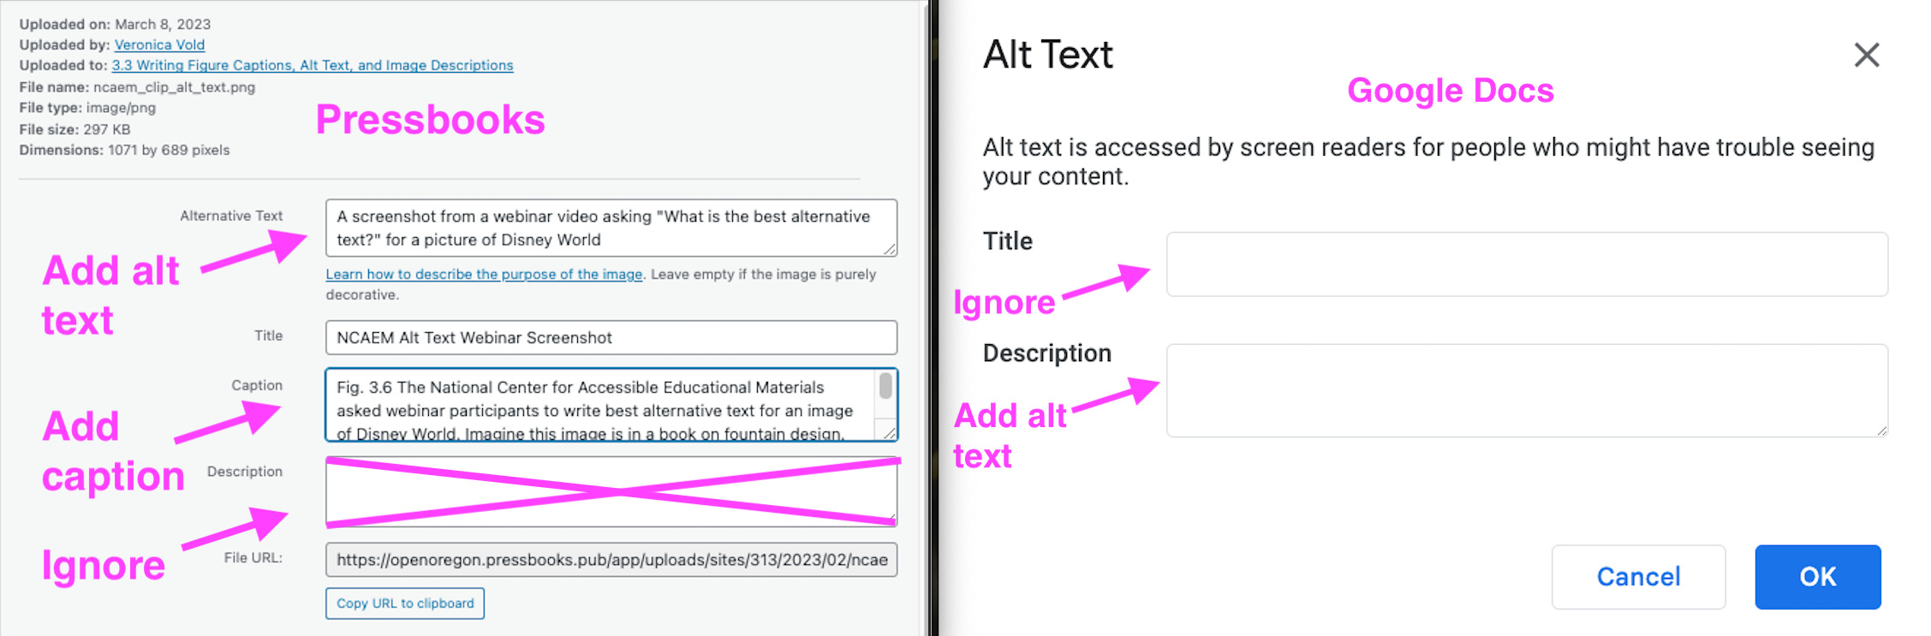

Screen Reader Demo: Missing Alt Text
Screen reader software and user preferences vary on reading speed and settings, but alt text is a universal expectation for informative images. Watch this screen reader user demonstrate what happens when an image is missing alt text. As the user points out, what if this was an assignment? What does missing alt text communicate about who belongs and who does not?

Fig. 3.5 A demonstration of screen reader software by a screen reader user produced by Colorado State University Assistive Technology Resource Center (ATRC).
One or more interactive elements has been excluded from this version of the text. You can view them online here: https://openoregon.pressbooks.pub/dothework/?p=471#oembed-1

Alt text Examples
Keep in mind: Alt text for the same image will be different depending on its purpose and use. This is why we ask revising authors to write alt text: alt text is most effective when it relates to the claims and learning objectives of a chapter section.

Alt Text Example 1
In a 1-minute video clip from a webinar from the National Center on Accessible Educational Materials [YouTube], presenters pose a question to participants: What’s the best alt text for this image from Disney World?

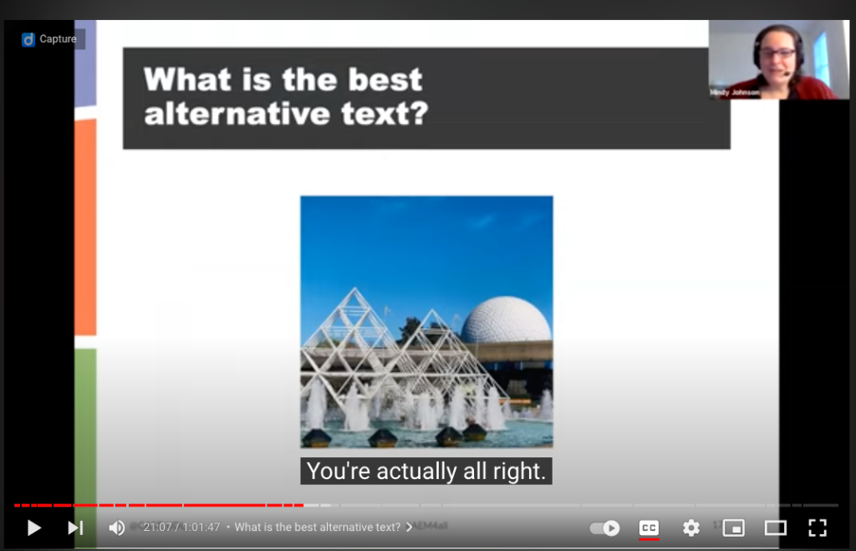

Turns out, this is a trick question! “You’re actually all right,” the presenter reveals. Without knowing the context or purpose for the image, the alt text for this image could focus on any number of features: geographical location, contrasting color, weather conditions, or architecture. The list is long! And without a clear purpose, it will be quite random! This is why the role of the revising author is so critical to writing alte text. Nobody wants it to be random. And ultimately, the revising author is the person best situated to determine the purpose for an image and the best alt text.
For additional examples of how alt text for the same image differs by purpose for decorative, functional, and informative images, visit WebAIM’s Alternative Text [Webpage].

Alt Text Example 2
An interactive H5P element has been excluded from this version of the text. You can view it online here:
https://openoregon.pressbooks.pub/dothework/?p=471#h5p-14

Writing Image Descriptions
While alt text is a short phrase that captures only the most important information about an image, and figure captions usually summarize or synthesize information in a few sentences, image descriptions include rich detail and context. As accessibility advocate Veronica Lewis notes, “alt text tells someone that there’s a puddle on the floor, and image description tells someone that the puddle on the floor is in the middle of the floor and it’s orange juice” (“How to Write Alt Text and Image Descriptions for the Visually Impaired” [Blogpost]).
Image descriptions help all users understand language, relationships, and actions they otherwise might miss. By using image descriptions, authors often make the content of an image more transparent not only to users but to themselves!
To write image descriptions, use the following guidelines:
- Keep the image description to a few sentences. The goal of an image description is to provide more context and detail than the alt text alone. It should not repeat the alt text but add something new.
- When describing people in image descriptions, include emotions when relevant. If facial expressions and body language communicate emotions (anger, joy, fear) that are relevant to the purpose of using the image, describe them.
- Just like when writing alt text, when describing people, don’t assume race or gender. Unless someone’s race or gender is self-described, do not assign people social identities. You can use terms like “dark skin tone” or “light skin tone” and note hairstyle, clothing, and physical build. Remember: the Targeted Pathways project aims for diverse representation in images. Alt text should also follow these choices.
- If the image includes words or numbers, write them out. If an image is an infographic or chart, it will likely include a great deal of information. It’s okay to allow the image description to run longer if this is the case.
- Don’t forget to note relevant details about the setting of an image. You might choose to describe the visual perspective of the image (close-up, bird’s eye view, high-angle, low-angle), the weather conditions, the lighting, different figures or creatures, or visual textures.
- Place the image description near the image in the text of the page. In Pressbooks, a link to the image description will be adjacent to the image for ease of reference. It’s fine to create a separate Google doc for each image description and link it next to the image in your chapter document. Please see examples below:

Image Description Example 1
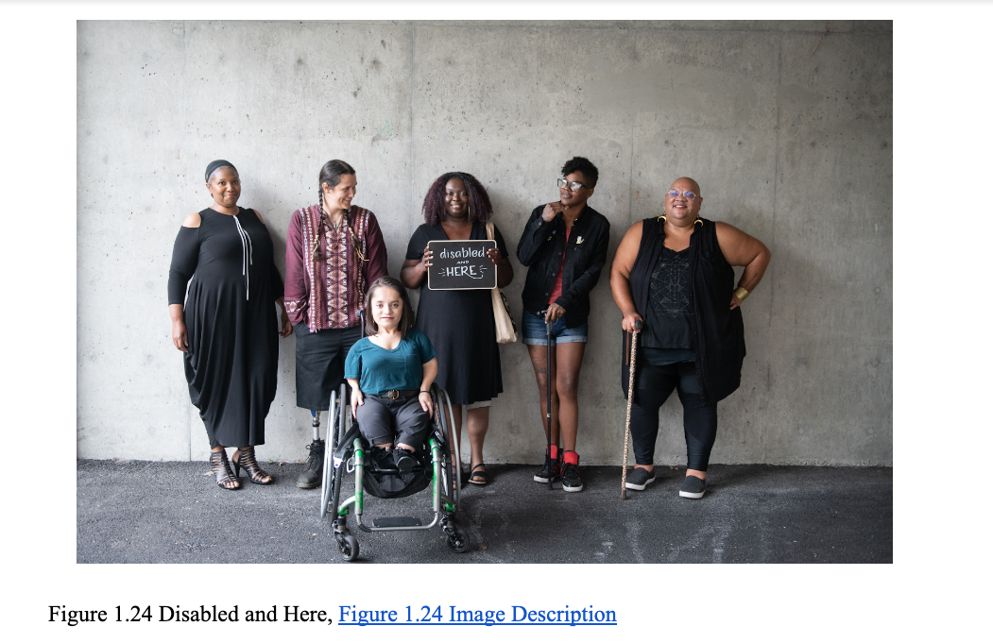
Alt text: A group of people of color with a range of disabilities pose together (Image Description Available)
Image Description for 1.24 from Disabled and Here [Website]: Six disabled people of color smile and pose in front of a concrete wall. Five people stand in the back, with the Black woman in the center holding up a chalkboard sign reading “disabled and here.” A South Asian person in a wheelchair sits in front.

Image Description Example 2
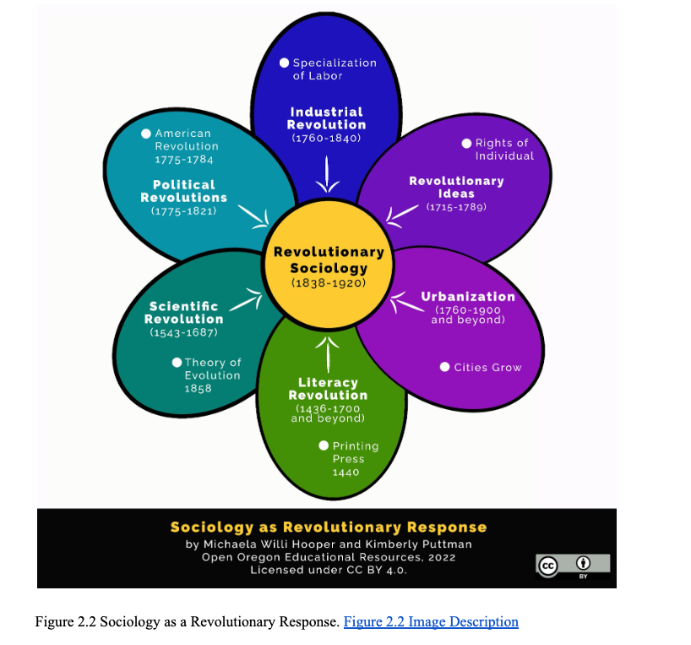
Alt text: A flower with six petals each featuring a revolutionary response (Image Description Available)
Image Description for 2.2:
A flower shape with a yellow center that says Revolutionary Sociology (1838-1920). There are six petals around the center. One petal says Industrial Revolution (1760-1840), specialization of labor. Another petal says Revolutionary Ideas (1715-1789), rights of individual. Another says Urbanization (1760-1900 and beyond), cities grow. Another says Literacy Revolution (1463-1700 and beyond), printing press (1440). Another says Scientific Revolution (1543-1687), theory of evolution (1858). Another says Political Revolutions (1775-1821), American Revolution (1775-1784). Below the flower the title says Sociology as revolutionary response. Creators Michaela Willi Hooper and Kim Puttman are noted along with the CC BY Creative Commons license.

Self-Comprehension Check
An interactive H5P element has been excluded from this version of the text. You can view it online here:
https://openoregon.pressbooks.pub/dothework/?p=471#h5p-17

Licenses and Attributions

Open Content, used previously
“Writing Figure Captions” is adapted in part from “Figures and Tables” by Susan Last in Technical Writing Essentials is licensed Creative Commons Attribution 4.0 International License
Image: Collaboration” by bre pettis is licensed CC BY-NC 2.0.
Image: How would you improve the alt text for the situation and purpose described below? Select any answer to see suggestions Question set features LGBT Love by @Planetnehemiah for nappy.co is licensed CC0.
Image: Screenshot of Figure 1.24 Disabled and here group shot by Disabled And Here is licensed CC-BY.
Image: Screenshot of Figure 2.2 “Sociology as Revolutionary Response” by Michaela Willi Hooper and Kim Puttman for Open Oregon Educational Resources [Website] is licensed CC BY
Open Content, original
All other content by Veronica Vold for Open Oregon Educational Resources [Website] is licensed CC BY 4.0.
Attributions

Figure 1.2. “Collaboration” by bre pettis is licensed CC BY-NC 2.0.

7

3.4 What are Descriptive Links?
Veronica Vold
Students with a range of disabilities need to access resources linked in your chapters. Writing descriptive links ensures that all students can benefit from your content.
Please note: links used in attributions and citations sometimes do not include descriptive text or a destination in brackets according to Creative Commons license statements and citation conventions. The following guidance applies to those resources linked within the chapter content itself.

Create descriptive link text
You need to ensure that chapter links have text that describes the topic or purpose of the link. This is important because people using screen reader software might have their screen reader set to read out the text for each link on a page. As such, the link text must describe the content of the link when taken out of context for the surrounding paragraph. While link texts such as “click here” or “read more” will make sense to sighted users, they mean nothing when read on their own.
Example 1: Click here for information on Open Oregon Educational Resources.
Example 2: You can find more information on Open Oregon Educational Resources at: openoregon.org
Example 3: Visit Open Oregon Educational Resources [Website] to learn more about what is happening across the state.
While the first two examples make sense in the context of the sentence, neither link text describes the purpose of its link. While the second example is better than the first, having the web address as the link text still does not make the purpose of the link clear. The third example is the most accessible.

Add the link destination in brackets
When incorporating a resource in the body of a chapter, It is best practice to include the destination of a link in the link text itself. This ensures that users know where they are going! It also helps users to decide if they want to select a link at a given time. A streaming video, for example, may require too much bandwidth for their present Internet speed and they might save it for later. Users also may choose not to download a linked file given the device they are currently using. Adding this information helps users make the most of their learning experience.
Here are some examples of how to add link destinations as part of the descriptive text of the link:
- Designing with Open and Equity-Minded Images by Heather Blicher [Google Slides]
- Tiny Survival Guide [Online PDF]
- OER Basics from Open Oregon Educational Resources [YouTube Video]

Self-Comprehension Check
After reviewing this page, test your knowledge with the true/false questions below!
An interactive H5P element has been excluded from this version of the text. You can view it online here:
https://openoregon.pressbooks.pub/dothework/?p=662#h5p-16

Licenses and Attributions

Open Content, used previously
Definitions and examples of descriptive links are adapted in part from “Links” in Accessibility Toolkit – 2nd Edition by BCcampus licensed under a Creative Commons Attribution 4.0 International License
Open Content, original
All other content by Veronica Vold for Open Oregon Educational Resources [Website] is licensed CC BY 4.0.

8

3.5 Media Captions and Transcripts
Veronica Vold
Our textbooks are designed with Oregon students in mind. This means that chapter length and total minutes of media engagement are aligned with weekly course credit hours and anticipated student workloads. Using the Course Workload Estimator from Rice University [Website], we estimate that on average, students will read about 132 words/minute, in addition to engaging in total minutes of multimedia content. Keep in mind that reading speeds vary widely between students, and how fast a student reads is not the same thing as how well a student understands the content. If chapters are 10,000 words or less, and about 20 minutes total of multimedia is interspersed throughout a chapter at regular intervals, students can expect to take between 90 and 120 minutes to read a chapter. Also note that when content is new, reading speeds will necessarily be slower than when content is more familiar.
Incorporating media into your textbook ensures that students aren’t bogged down in heavy blocks of endless text. This is a key principle for Universal Design for Learning. Multiple means of representation ensures that students can listen to audio or access video files and images, or analyze graphs and charts in order to engage in course content. Meaningful audio, video, and graphics support attention and focus in ways that text by itself fails to do. However, if audio isn’t accurately captioned, students who are Deaf or hard of hearing won’t be able to access this content. English language learners will miss key information. Students who are studying with sound off while on public transit won’t be able to accurately follow along. Accurate media captions ensure that students have an equitable opportunity to engage.In addition to media captions, an accurate transcript is a key step in tracking information and synthesizing complex ideas.

What are media captions and transcripts?
Media captions provide a running transcription of audio content that is synched up to an audio or video file. As 3PlayMedia notes, machine-generated automatic media captions are often about 80% accurate [Website]. This means that they need manual review and editing by a person in order to provide equitable access. To assess the quality of media captions, watch or listen for a few minutes with captions turned on. Typically names, dates, locations and complex vocabulary words need to be manually edited. If you see typos or misspellings in media captions that don’t align with the audio you hear, it’s likely that they have not been edited for accuracy.
Transcripts provide the full transcription of audio content in a media file. They are often key word searchable and offer an alternative to watching a video in order to receive content. Transcripts are excellent for students who can read more efficiently than they process auditory information. Transcripts are also important for students who want to accurately cite or quote something they learned from engaging with the multimedia.

What to do if captions are missing or inaccurate
Our project team can request that multimedia content creators generate and edit media captions for accuracy. You can initiate a media development request for media captions by emailing Phoebe Daurio at dauriop@linnbenton.edu.
If this request is denied but the media is openly licensed and allows derivatives, we can create accurate captions and transcripts. If the media is all rights reserved and content creators do not grant permission, the revising author will need to find other accessible media as a substitute. You can begin the process of requesting permissions for editing media captions by emailing Phoebe Daurio at dauriop@linnbenton.edu.

What to do if there is no transcript or if it’s inaccurate
YouTube has a new transcript function that allows users to view and download the full transcript of a video. If the transcript is inaccurate, we’ll follow the same steps as above.
For most videos with captions, you can view the full captions transcript, and jump to specific parts of the video:
- Go to the video description, and click More.
- Click Show transcript. As you watch the video, the transcript will scroll to show you the current caption text.
- Click any line of caption text to jump to that part of the video.
To initiate a media development request, email Phoebe Daurio at dauriop@linnbenton.edu.

Licenses and Attributions

Directions for viewing YouTube transcript from “Manage subtitle settings” © YouTube Help used under fair use.
All other content by Veronica Vold for Open Oregon Educational Resources [Website] is licensed CC BY 4.0.

3.6 Apply and Submit
Veronica Vold

Instructions for Apply and Submit
- Please read the entire module before completing the Apply and Submit activity.
- Go to your “Revising and Feedback Documents (Year 2 & 3)” folder in your Google Drive author folder.
- Open the document titled “Doing the Work: Apply and Submit Activities (Modules 1-5)”
  - Read the Activity Prompt for Module 3.
  - Complete the activity in the Revising Author Submission column for Module 3.
  - You can complete the activity in an optional Zoom workshop meeting (link below) or on your own.

- Submit the activity for feedback using the Doing the Work Apply and Submit Google Form by Monday, April 10, 9am.

Optional Zoom workshop meeting information:
- Attend a 50-minute Zoom meeting to complete the activity, ask questions, share, and get feedback on your work before submitting.
  - Friday, April 7, 3-3:50 pm, https://linnbenton.zoom.us/j/93346954523

IV

Module 4: Building OER Together for All: Attributions, Access, and Authorship
Click on the + in the Contents menu to see all the parts of this chapter, or go through them in order by clicking Next → below

4.1 Overview
Michaela Willi Hooper

Learning Objectives
- Define how to include third-party materials in a copyright-compliant way as defined through a DEI lens.
- Use the Attributions Style Guide to create attributions for the revised manuscript.
- Identify when to get support for identifying open materials and creating attributions.
- Explain how you can adapt an original source that requires equity revision.
Many times, both in this text and elsewhere, you may have heard the terms open, open educational resources, and/or open licensing. It’s likely you still have some questions, like:
- What precisely do we mean by “open” in the context of this project?
- Why is openness important to diversity, equity, and inclusion?
- Can I include content that isn’t open?
- How do I attribute open educational resources?
- What else do I need to be aware of when using or creating open educational resources?
The following three sections address these questions. At the end of each section is a self-check. If you have questions or need help, please reach out to research consultant Michaela Willi Hooper (michaela@taowebsites.com).

9

4.2 How Copyright Laws Created the Need for Open Licensing
Michaela Willi Hooper and Marco Seiferle-Valencia
UNESCO (n.d.) defines Open Educational Resources as:
Learning, teaching and research materials in any format and medium that reside in the public domain or are under copyright that have been released under an open license, that permit no-cost access, re-use, re-purpose, adaptation and redistribution by others.
This definition is meaningful only because most creative works are automatically copyrighted as soon as they are fixed in a “tangible medium of expression” (U.S. Copyright Office, n.d.). In other words, as soon as you write an email, record a piece of music, jot a poem on a piece of paper, or film your cat doing something cute, the law says you hold the copyright to that creative work (along with any human co-creators). Under copyright, copyright holders have the exclusive rights to make and distribute copies, develop derivative works, and to perform or display works publicly. They can bring lawsuits against people and institutions who use their work without permission (although it is more likely for them to contact potential infringers with a takedown notice, first).

All Rights Reserved vs. Copyrighted
Copyright automatically gives copyright holders many exclusive rights. Throughout this text, we will refer to this default copyright as All Rights Reserved. Why? Because open licenses, discussed later in this module, don’t eliminate copyright. Instead, they allow creators to choose the rights they want to share with others.
The first United States copyright law was enacted in 1790, based on Great Britain’s Statute of Queen Anne (1710). While copyright is intended to protect creators, it also has disadvantages. Copyright has become more restrictive over time, and, since it’s now applied automatically, many creators hold copyrights without knowing they have them. Here are some the consequences of this system.

All Rights Reserved materials and permissions may be difficult, expensive, or impossible to procure
Unless the copyright holder takes steps to mark their work, it can be difficult to determine who holds the copyright, especially when it has been reshared and revised many times. Sometimes creators have died and it’s difficult to determine who inherited their estate, or there is no contact information available for a creator. Even if you can contact the person or organization with the right to give you permission, they might not respond or deny you permission.

All Rights Reserved materials may be too expensive to access, especially for under-resourced people and communities
Publishers may also set the price too high for under-resourced people and institutions to access. If you live in Oregon, you likely have access to one or more libraries, which pay for permission, or licenses, to provide access to copyrighted digital resources like articles, music, art, and ebooks for their users. Unfortunately, not everyone has access to well-resourced libraries. College and university libraries pay for faculty and enrolled students to access academic journals and ebooks that can be prohibitively expensive for recent graduates and other people outside academia. At many institutions, students must still purchase their own textbooks. Research shows OER improve grades for all students, and especially benefit students from historically underserved backgrounds (Colvard et al., 2018).

Copyright is not always held by the creators
Copyright evolved in 18th century Europe, when authors relied on publishers to distribute their work. Today, it is still common for authors to transfer their copyright to publishers. Some authors (particularly famous ones) are compensated for their works.
Scholars, however, often write research articles and chapters for free, funded by institutions or governments. It used to be standard practice for scholars to transfer the copyright of their works to publishers, who then sell the published works back to colleges and universities via their libraries. The campaign for academics to retain their copyrights and make research available to everyone is called the open access movement.

Copyright as a Colonial Endeavor
Copyright laws represent the imposition of a Western practice of knowledge ownership, which is in conflict with many Indigenous viewpoints on knowledge and attitudes towards intellectual property ownership. While we must always avoid reductive, monolithic thinking when it comes to Native people, it is generally true that most Native and Indigenous traditions have long standing practices of oral traditions and knowledge transmission.
Western researchers may be the first ones to “fix,” or write down, traditional knowledge. In some cases, these transcriptionists have claimed ownership and failed to compensate the communities who generated the knowledge. This type of theft is facilitated by the individualistic framing of copyright laws. The World Intellectual Property Organization says,
Traditional knowledge is not so-called because of its antiquity. It is a living body of knowledge that is developed, sustained and passed on from generation to generation within a community, often forming part of its cultural or spiritual identity. As such, it is not easily protected by the current intellectual property system, which typically grants protection for a limited period to inventions and original works by named individuals or companies. Its living nature also means that “traditional” knowledge is not easy to define. (World Intellectual Property Organization, n.d.)
Traditional Knowledge Labels, also known as TK Labels, intend to help non-Native Institutions present and share Native belongings with culturally informed context and, sometimes, restrictions. Native nations who collaborate with Local Contexts can use TK Labels to help digital belongings have some of the correct rights and contexts that are currently missing from Western methods of copyright. It is important to note that TK Labels can express a community’s wishes for how an item is displayed or shared, but they are not legally enforceable licenses.
Many Indigenous and Native researchers in this area are currently working on developing Indigenous first knowledge systems, without colonial intervention. One example is the Respectful Terminology Project, which is an Indigenous-led effort to challenge current harmful language practices in Galleries, Archives, Libraries and Museums.
Copyright is a legal framework within imperfect and evolving social and political institutions. While copyright compliance is important, a DEI framework might also ask:
- Are there any contributors who have been left out, not acknowledged, or not compensated?
- What can we do to correct power imbalances that have enabled some people to take credit for other people’s work, traditions, and creativity?
- How do we acknowledge all contributors clearly, concisely, and consistently?

Fair use isn’t always a practical solution
There are some exceptions to copyright law, including fair use. Fair use is built on case law and can be difficult for educators to apply. Not every instructor receives copyright training, and institutional policies vary in their level of support. Fair use generally doesn’t permit widespread, free sharing of entire works without the express permission of the copyright holder. For this, we need to look beyond “all rights reserved” content to public domain and openly licensed content.

Self-Check
Test your knowledge of copyright basics.
An interactive H5P element has been excluded from this version of the text. You can view it online here:
https://openoregon.pressbooks.pub/dothework/?p=167#h5p-2

Licenses and Attributions

Open Content, Original
“Copyright as a Colonial Endeavor” by Marco Seiferle-Valencia and Michaela Willi Hooper is licensed under CC BY 4.0.
All other content by Michaela Willi Hooper is licensed under CC BY 4.0.

References
Colvard, N. B., Watson, C. E., & Park, H. (2018). The impact of open educational resources on various student success metrics. International Journal of Teaching and Learning in Higher Education, 30(2), 262–276. https://eric.ed.gov/?id=EJ1184998
UNESCO. (n.d.). Open Educational Resources. https://www.unesco.org/en/open-educational-resources
U.S. Copyright Office. (n.d.). Subject matter and scope of copyright. Copyright Law of the United States. https://www.copyright.gov/title17/92chap1.html#101
World Intellectual Property Organization. (n.d.)Traditional knowledge and intellectual property – Background brief. https://www.wipo.int/pressroom/en/briefs/tk_ip.html

4.3 The Public Domain and Why Remixing Matters
Michaela Willi Hooper

The Public Domain: Out of Copyright
Public domain materials come with no copyright restrictions! They include:
- Anything published before 1928.
- Many things published between 1928 and 1989. Copyright status can be difficult to determine for materials from this time period. See this chart from Cornell for more details.
- Content created by employees of the U.S. federal government and its agencies (CDC, NIH, DOJ, USDA, etc.) in the line of their work. Be cautious when federally funded materials have personal names or other institutions listed as well. These may not be clearly in the public domain. Check with your research support person if you’re not sure.

Using Public Domain Materials Critically and in Context
Just because a work is not copyrighted does not mean it is credible or appropriate. Older works and government publications should include appropriate context, criticism, and commentary. Here are three examples of when you might use public domain materials:

Federal Agency Data
Federal agencies like the FBI and the Census Bureau are often cited as primary sources of criminal justice and demographic statistics. These agencies’ publications, including charts and reports, are in the public domain. But it’s also important to note the limitations of these sources. You might include alternative projects like Mapping Police Violence, as well as critiques of government data, like this article from ProPublica on mislabeling hate crimes.

Images of Historic People and Events
Images created before 1928 are in the public domain. Elizabeth Pearce and student contributors to Contemporary Families remixed two texts in their chapter on “Working Outside of the System: Social Movements and Activism” and included public domain images of key historic people and events, including a portrait of journalist Ida B. Wells (Figure 4.1).

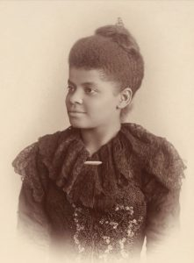

Public Domain Illustrations
In addition to photographs and charts, many projects are also including illustrations. Many illustrators have dedicated their works to the public domain through a CC0 mark, including Pablo Stanley, creator of OpenPeeps. There are no legal restrictions on remixing or creating new works using public domain images. This is an important right for educators, which we’ll discuss in the next section.

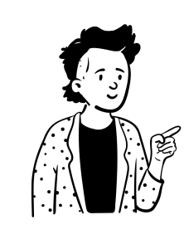

Legally, you don’t need to attribute public domain materials, but, of course, attribution or citation is important for other reasons, including:
- Avoiding plagiarism. Even if a creator is no longer living, or is a government employee, giving credit is the right and professional thing to do.
- Being credible. Students are taught to Investigate the Source as part of college information literacy programs. Providing source information, where possible, bolsters your credibility and helps curious readers dive deeper.
- Tracking it down later. Keeping records of your sources also helps you. Sometimes you can use Google’s Reverse Image Search to track down an image source, but not always. It’s also way more time-consuming than attributing sources right away!
We’ll discuss how to attribute public domain materials in more detail in section 4.5, or you can see examples in the attributions guide.
Anyone can dedicate their work (if they hold the copyright, i.e., didn’t make it for an employer or transfer it to a publisher) to the public domain by applying the CC0 mark. Why would someone want to give their work away for free, without requiring attribution? Because sometimes that’s the most responsible or effective way to share a resource. For example, many researchers put their data in the public domain because data are often not copyrightable, anyway (see box). It can also be cumbersome to attribute when working with massive numbers of data sets. Retaining at least the right to attribution with a Creative Commons Attribution (CC BY) license is more common for authors of books, articles, and images.

What Can Be Copyrighted?
Not everything can be copyrighted. Copyright applies to creative works like books, movies, art, music, and architecture. The telephone book, numerical data (like measurements), and exact copies of public domain works are not creative enough to be copyrighted. Ideas and facts cannot be copyrighted, but the specific way they’re worded or presented (if creative enough) can be. This means:
- You can generally reproduce numerical/statistical data in a table as long as you don’t copy the design. Bonus: A text table is also more accessible to screen readers! If you’re not sure if something you want to use would be copyrighted, talk to your campus copyright expert or the research consultant.
- You can paraphrase facts and ideas without copyright restrictions. Remember that plagiarism and copyright violation are different! If someone came up with an idea or conducted a study, citing is still the professional and ethical thing to do.
There are other types of intellectual property besides copyright. These include patents and trademarks, which protect inventions and company brands. Educators and authors primarily deal with copyright. Remember that copyright is automatic, so even if a book, image, or video doesn’t have a (c) symbol, you can assume it’s copyrighted unless it meets one of the public domain criteria, above.

How Copyright Affects Remixing

The Five Rs
The adaptability and reusability of OER make it so that they are not just free to access, but also free for instructors who want to alter the materials for use in their course. Remember The Hewlett Foundation’s definition of OER: “Teaching, learning and research materials in any medium – digital or otherwise – that reside in the public domain or have been released under an open license that permits no-cost access, use, adaptation and redistribution by others with no or limited restrictions” [emphasis added]. We’ve just discussed the public domain, and the next section will cover open licenses like Creative Commons.
One of the tenets of OER laid out early on in the open education movement was the idea of the 5 Rs (originally the 4 Rs) introduced by David Wiley (2014). These five attributes lay out what it means for something to be truly “open,” as the term is used in open education. The 5 Rs include:
- Retain = the right to make, own, and control copies of the content.
- Reuse = the right to use the content in a wide range of ways
- Revise = the right to adapt, adjust, modify, or alter the content itself
- Remix = the right to combine the original or revised content with other open content to create something new
- Redistribute = the right to share copies of the original content, your revisions, or your remixes with others
Each of these five rights plays an important role in the usefulness of an open educational resource. For example, without the right to remix materials, an instructor would not be able to combine two different OER into a new resource that more closely fits their needs. The right to revise is particularly important from an equity perspective, as discussed in Module 2: Textbook Revision.
Each of the 5 Rs are the exclusive right of the copyright holder unless a work is in the public domain or openly licensed. In the next section, we’ll look at Creative Commons licenses and how they facilitate the expression of the 5 Rs in unique ways. It’s important to understand the different kinds of licenses because not all Creative Commons licenses allow revising and remixing.
Watch the video below (Figure 4.3) for a short, clear overview of how copyright and licensing led to the need for open licenses like Creative Commons, which we’ll discuss next.
One or more interactive elements has been excluded from this version of the text. You can view them online here: https://openoregon.pressbooks.pub/dothework/?p=615#oembed-1

Self-Check
Test your knowledge of the rights you have with public domain materials compared to All Rights Reserved materials.

An interactive H5P element has been excluded from this version of the text. You can view it online here:
https://openoregon.pressbooks.pub/dothework/?p=615#h5p-11

Licenses and Attributions

Open Content, Shared Previously
“How Copyright Affects Remixing” is adapted from “Copyright and Open Licensing” by Abbey Elder, The OER Starter Kit, which is licensed under CC BY 4.0. Modifications: Changed structure, expanded, edited, and abridged.
Figure 4.1. “Ida B. Wells Barnett” by Mary Garrity, restored by Adam Cuerden, is in the Public Domain.
Figure 4.2. Image by Pablo Stanley, OpenPeeps, is CC0.
Figure 4.3. “What is an open license and how does it work?” by The Council of Chief State School Officers is licensed under CC BY 4.0.
Open Content, Original
All other content by Michaela Willi Hooper is licensed under CC BY 4.0.

References
Wiley, David. (2014). Defining the ‘open’ in open content and open educational resources. Open Content blog. http://opencontent.org/definition

10

4.4 Open Licenses: Creative Commons and Beyond
Michaela Willi Hooper

Creative Commons Licenses: Some Rights Reserved
As we’ve discussed, by default, copyrighted works are under full, “all rights reserved” copyright. This means that they cannot be reused in any way without permission from the work’s rightsholder (often the creator). One way you can get permission to use someone else’s work is through a license, a statement or contract that allows you to perform, display, reproduce, or adapt a copyrighted work in the circumstances specified within the license. For example, the copyright holder for a popular book might sign a license to provide a movie studio with one-time rights to use their characters in a film.
All OER are made available under some type of open license to the public, which are flexible enough to meet the creators’ intended vision of future use. The most popular of these open licenses are Creative Commons (CC) licenses, customizable copyright licenses that allow others to reuse, adapt, and re-publish content with few or no restrictions. CC licenses allow creators to explain in plain language how their works can be used by others. These licenses act as explicit, standing permissions for all users.
Below are the four possible components of a Creative Commons license:
Attribution (BY)
Share-Alike (SA)
Non-Commercial (NC)
No Derivatives (ND)
These elements can be mixed and matched to create a total of six Creative Commons licenses. You can learn more about the individual CC licenses on the Creative Commons website.

Caution! Not All Creative Commons Licenses Are Fully Open
If you want to reuse an existing OER, there are some aspects of CC licenses you should keep in mind. Although there are different rules for each, every CC license includes the Attribution component, which requires that users provide proper attribution for an original work being shared or adapted. Attributions will be covered in the next section. Figure 4.3 shows how being open can be seen more as a spectrum than a binary, with public domain at the most open end, and All Rights Reserved copyrighted materials at the other.

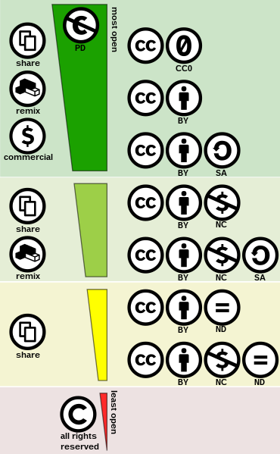

It’s important to be aware of the practical restrictions with the No Derivatives (ND) and Share-Alike (SA) licenses when remixing:
- When materials are under a license that includes the No Derivatives (ND) component, they should not be remixed or revised. As an example, it’s fine to insert an unedited picture under an ND license, but you do not want to copy and paste paragraphs from ND works into your text or edit ND works. If you’re not sure if your use might constitute revising or remixing, talk to a librarian or the research consultant.
- Materials that are licensed under the Sharealike (SA) component should only be remixed with compatible licenses. In other words, CC BY-NC-SA-licensed content should not be remixed with CC BY-SA-licensed content. Because both of these licenses have the Sharealike but are different (one is Noncommercial), it’s not recommended to mix them in the same chapter or section. As with ND licenses, license compatibility for unedited image inserts within the same chapter are not a concern.
- The distinction between including an unedited image and remixing text may seem small and confusing. A helpful metaphor is Nate Angell’s distinction between a smoothie and a TV dinner. When you modify and combine text from multiple sources, you’re creating a new thing (a derivative), like a smoothie. When you’re inserting an unedited image, it’s still easily distinguished as the same image, just like carrots are still carrots, even once they’re placed in a TV dinner.
These license exist to give authors some control over their works. For example, people sharing art or personal memoirs may be protective of the integrity of their work and choose the ND component. Your work will also be Creative Commons-licensed, which is discussed further under “Choosing a License for Your Book,” below. Remixing material under different licenses is one of the more complex parts of working in the open. If you find some of this confusing, you’re not alone. The OER project consultants and your friendly librarians are available to help.

Other Types of Licensing
Creative Commons licenses are often found at the bottom of a website, sometimes under links that say copyright or terms and conditions. Sometimes these terms and conditions give custom permission for educational or nonprofit use. Because these permissions are often vague and don’t spell out exactly what is permitted like Creative Commons licenses, it’s best to check with your librarian or the research consultant before using content with custom licenses or terms. It’s especially important to make sure text you use is under a standard open license like Creative Commons.
Pixabay, Unsplash, Pexels, and the Standard Youtube License have licenses that allow you to insert images and embedded videos from these sites. You can find examples of how to attribute them in the attributions guide.

Finding Open Content for Your Book
Writing a book is iterative, and your reviewers may have noted sections you would like to expand or find more diverse examples for. Librarians and the OER Research Consultant are happy to help and have special training in available collections and searching techniques. You’re also free to explore the open-verse for yourself! The Open Oregon Educational Resources FAQ suggests collections of open textbooks, images, and ancillaries to get you started. Google also allows you to filter searches for openly licensed images and other content, although I recommend using caution and verifying the licensing on the page itself.

Self-Check
Use the activity below to reinforce your understanding the Creative Commons license components.
An interactive H5P element has been excluded from this version of the text. You can view it online here:
https://openoregon.pressbooks.pub/dothework/?p=174#h5p-12

Licenses and Attributions

“Open Licenses: Creative Commons and Beyond” is adapted from “Creative Commons Licenses” by Abbey Elder, The OER Starter Kit, which is adapted from The ABOER Starter Kit and is licensed under CC BY 4.0. Modifications: Changed structure, expanded, edited, and abridged.

Open Content, Shared Previously
Figure 4.4. “Creative commons license spectrum” by Shaddim is licensed under CC BY 4.0.
Open Content, Original
All other content by Michaela Willi Hooper is licensed under CC BY 4.0.

4.5 Attributions: Giving Credit
Michaela Willi Hooper

Attributions: Giving Credit

Attributions vs. Citations
We’ve already discussed why giving credit is important. There are two primary ways of giving credit: attributions and citations. It can be confusing to know when to cite and when to attribute. The table below can help you decide.
 | Citation | Attribution
Purpose | Professional (avoiding plagiarism) | Legal (license compliance) and professional
Copyright/licensing information included? | No | Yes
When do I use one? | When you paraphrase, refer to a work, or use a short quote of a few sentences in quotation marks. | When you copy, revise, or remix a portion or entirety of a work under an open license, fair use, or with permission. All embedded images and videos should have attributions.
Style/format | Your author team decides and documents in your style sheet whether you will use APA, ASA, Chicago, or a custom style. | Attribution Style Guide
Location | Most books in this project use parenthetical (Author, Date) citations with a reference list at the end of the chapter. | Most books in this project are putting attributions in a Licenses and Attributions box at the end of each Heading 2 section (which will be a page in Pressbooks).
Figure 4.5. Comparison of citations and attributions.

Citation Justice and Diversity
In response to the lack of diversity in many academic fields, some scholars are choosing to include citation diversity statements (Zurn et al., 2020). This guide from the University Libraries at the University of Maryland is full of helpful resources and suggestions, including a database of scholars who identify as Black. The guide defines Citation Justice as “the act of citing authors . . . to uplift marginalized voices with the knowledge that citation is used as a form of power in a patriarchal society based on white supremacy.”

How to Create an Attribution
All images, text, and other content that you did not create (unless it is a short quote in quotation marks–see table above) should have an attribution that includes:

  - Title (when available)
  - Author or creator (when available)
  - Source (link or URL), and
  - Licensing or copyright information.
Licensing and copyright information is sometimes legally required, and always helpful for people who are remixing your books in the future. Here are some types of licenses and copyright used in the project:
- A Creative Commons license (CC BY-SA 4.0, CC BY-ND 4.0, etc.).
- In the Public Domain.
- The Standard YouTube License or another custom license like Pexels, Pixabay, or Unsplash.
- All rights reserved copyright. Remember, this is the default if none of the above apply! When you absolutely need to use this material, your options are:
  - Included with permission.
  - Included under fair use.

Using the Open Attribution Builder to Generate a Basic Attribution
The Attribution Style Guide provides examples of how to attribute common types of content. The style used is based on the WA Open Attribution Builder, which you can use to easily generate attributions for open content. It works especially well for images. When I create attributions for books, I put the book chapter in Title field and the book title in the Project field.

Adding Specific Location Information
The Open Attribution Style Builder does not know what part of your book you’re talking about, so you have to add this information (usually a figure number or subsection title). For future users, it’s important to be clear what part of your work is built on an adapted work.
For example, the following attribution is copied directly from the Open Attribution Builder:
“Which Nationalities Consider Religion Most Important?” by Niall McCarthy, Statista is licensed under CC BY-NC-ND 4.0
Here is the same attribution with a figure number, which you would customize depending on where it’s placed in your book:
Figure 1.1. “Which Nationalities Consider Religion Most Important?” by Niall McCarthy, Statista is licensed under CC BY-NC-ND 4.0.

Adding Modification Information
If you changed someone’s work (edited, shortened, expanded, etc.), it’s a best practice to note these adaptations or modifications at the end of your attribution.

Attributions and Citations Within Copied/Attributed Open Materials
Often the material you are copying will also have citations and attributions. What do you do about those?

Citations
Since the purpose of including citations is to bolster your credibility and avoid plagiarism, you generally will copy over citations/references from open works you use and update the style to match the rest of your book’s style. Sometimes references are out of date, and you can work with your librarian or the research consultant to find more current studies and data.

Attributions
Sometimes OER are remixed from many sources and it can be difficult to figure out which attributions in the source you’re using should be copied over. In order to be clear about where embedded images and videos come from, attributions to figures and videos you include should always be copied over and formatted/numbered consistently with your other attributions. Some OER include figures under fair use without attributing them, but in this project all fair use images should include attributions. If you’re not sure where a figure came from, ask the research consultant or your librarian for help tracking it down.
Give credit as far back as possible, when reasonable. For example, if it’s clear that the section of an OER you’re using was adapted from another OER (a derivative), attribute both. In Figure. 4.6, below, you can see that the Open Attribution Builder has a field to provide a URL for a derivative work.

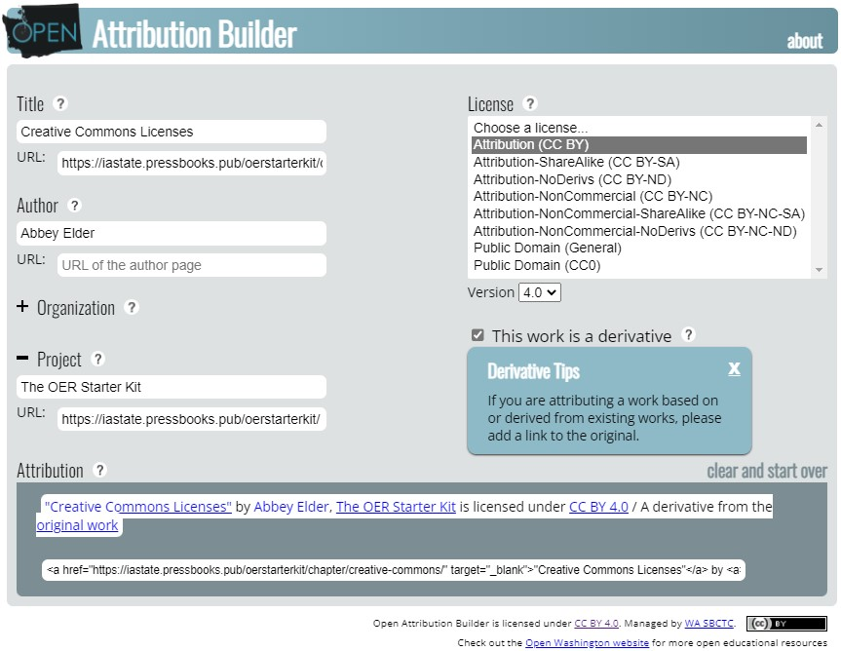

Sometimes, because not everyone provides detailed modification notes, it’s unclear if the specific content you’re using is remixed from a previous OER. In this case, it’s sufficient to attribute just the OER you’re using.

Crediting Your Author Team
It’s up to your author team to decide who is listed as a chapter author, book author, etc. Your Licenses and Attributions box will contain both information about works you have borrowed (attributions)and information about who contributed original work to your chapter and the terms of its use (licensing statements). See “Help People Attribute You” in the Attribution Style Guide for examples of how to do this.

Choosing a License for Your Book
The default project license for original works is CC BY 4.0. Talk to the research consultant if you want to use another license or are using a lot of Sharealike (SA) materials in your book. You may need to put chapters and original content where you use Sharealike materials under the same Sharealike license.

When What You Need Isn’t Open: Fair Use and Getting Permission
Hopefully you’ve used mainly open materials or your original work in your books. This is especially important for the main text. In some cases, you may not be able to find or create an adequate substitute for a culturally important but All Rights Reserved resource. The Code of Best Practices in Fair Use for Open Educational Resources is one of the most detailed and recent resources that Open Oregon Educational Resources points to in the FAQ on Fair Use. In the section on including inserts for the purpose of illustration, the Code calls out historically important photographs and advertisements as examples of images that you may decide to include under fair use:
Such illustrative uses represent the most common category of inserts used in all teaching materials (including OER) and are effectively indispensable to both instructional practice and learning. Typically, illustrative inserts were originally created in non-educational use contexts such as journalism, entertainment, or scientific documentation. Moreover, their learning value is closely associated with their authenticity, so they cannot be effectively “recreated.” (p. 12)
It’s up to you, as the author, to make a fair use decision because you are in the best position to judge what is indispensable. If in doubt, you can seek permisson. Find more strategies about what to do when you need to include All Rights Reserved resources.
It’sa best practice to attribute all materials you include, even those in the public domain or under fair use.

Questions?
Librarians are often knowledgeable about these topics. You are also welcome to reach out to the project research consultant, Michaela Willi Hooper, at michaela@taowebsites.com

Self-Check
Check your knowledge of Creative Commons attributions with the quiz below.
An interactive H5P element has been excluded from this version of the text. You can view it online here:
https://openoregon.pressbooks.pub/dothework/?p=73#h5p-5

Licenses and Attributions

Open Content, Shared Previously
Figure 4.5. Table is adapted from “
” by Abbey Elder,
, which is adapted from the
and is licensed under
Modifications: Customized for project standards.
Figure 4.6. Screenshot of The Open Attribution Builder by WA SBCTC, which is licensed under CC BY 4.0.

Open Content, Original

All other content by Michaela Willi Hooper is licensed under CC BY 4.0.

References
Center for Media and Social Impact. (2021). Code of best practices in fair use for OER. American University Washington College of Law. auw.cl/oer
Zurn, P., Bassett, D. S., & Rust, N. C. (2020). The citation diversity statement: A practice of transparency, a way of life. Trends in Cognitive Sciences, 24(9), 669–672. https://doi.org/10.1016/j.tics.2020.06.009

4.6 Apply and Submit
Michaela Willi Hooper

Instructions for Apply and Submit
- Please read the entire module before completing the Apply and Submit activity.
- Go to your “Revising and Feedback Documents (Year 2 & 3)” folder in your Google Drive author folder.
- Open the document titled “Doing the Work: Apply and Submit Activities (Modules 1-5)”
  - Read the Activity Prompt for Module 4.
  - Complete the activity in the Revising Author Submission column for Module 4.
  - You can complete the activity in an optional Zoom workshop meeting (link below) or on your own.

- Submit the activity for feedback using the Doing the Work Apply and Submit Google Form by Monday, March 17, 9am.

Optional Zoom workshop meeting information:
- Attend a 50-minute Zoom meeting to complete the activity, ask questions, share, and get feedback on your work before submitting.
  - Friday, April 14, 3-3:50 pm, https://linnbenton.zoom.us/j/98677622052

V

Module 5: Equity-Minded Course Revision
Click on the + in the Contents menu to see all the parts of this chapter, or go through them in order by clicking Next → below

1

Appendix
This is where you can add appendices or other back matter.

